**Berkeley 14 - 17 AI/ML Certificate Program Modules 14 - 17**

Prepare Journey Data, generalize and mask entries.!

Slack: Here's the announcement pointing to the Slack space.

Topic: Student Success Coaching and Slack Workspace Now Available!

(emeritus.org)

<https://student.emeritus.org/courses/4765/discussion_topics/257315>

* 941884802
* 639519956
* 622799832
* 576043581
* 614049009
* 594801975
* 478128440
* 894489611
* 750116839
* 537618010

**Savio’s Colab:**

<https://colab.research.google.com/drive/1m640WoWTbTgw0ymZoIw9K0wyCfMXtbYH#scrollTo=YdnBR4JQ_MMA>

One 1:1 Meeting per participant across the period of Weeks 12-15

June 8 - July 5

One 1:1 Meeting per participant across the period of Modules 21-23

August 17 - September 6

<https://student.emeritus.org/courses/4765/pages/how-to-schedule-a-1-1-session?module_item_id=999645>

<https://student.emeritus.org/courses/4765/pages/capstone-project-overview?module_item_id=999644>

<https://student.emeritus.org>

**An outline of the BH-PCMLAI program calendar**

|  |  |  |  |
| --- | --- | --- | --- |
| **Module #** | **Module Title** | **Week #** | **Date** |
| **0** | Program Orientation | 0 | **Wednesday, March 02, 2022** |
| **1** | Introduction to Machine Learning | 1 | **Wednesday, March 09, 2022** |
| **2** | Fundamentals of Machine Learning | 2 | **Wednesday, March 16, 2022** |
| **3** | Introduction to Data Analysis | 3 | **Wednesday, March 23, 2022** |
| **4** | Fundamentals of Data Analysis | 4 | **Wednesday, March 30, 2022** |
| **5** | Practical Application 1 | 5 | **Wednesday, April 06, 2022** |
| Break Week |  |  | **Wednesday, April 13, 2022** |
| **6** | Clustering and Principal Component Analysis (PCA) | 6 | **Wednesday, April 20, 2022** |
| **7** | Linear and Multiple Regressions | 7 | **Wednesday, April 27, 2022** |
| **8** | Feature Engineering and Overfitting | 8 | **Wednesday, May 04, 2022** |
| **9** | Model Selection and Regularization | 9 | **Wednesday, May 11, 2022** |
| **10** | Time Series Analysis and Forecasting | 10 | **Wednesday, May 18, 2022** |
| **11** | Practical Application 2 | 11 | **Wednesday, May 25, 2022** |
| Break Week |  |  | **Wednesday, June 01, 2022** |
| **12** | Classification and k-Nearest Neighbors (KNN) | 12 | **Wednesday, June 08, 2022** |
| **13** | Logistic Regression | 13 | **Wednesday, June 15, 2022** |
| **14** | Decision Trees | 14 | **Wednesday, June 22, 2022** |
| **15** | Gradient Descent and Optimization | 15 | **Wednesday, June 29, 2022** |
| **16** | Support Vector Machines (SVMs) | 16 | **Wednesday, July 06, 2022** |
| **17** | Practical Application 3 | 17 | **Wednesday, July 13, 2022** |
| Break Week |  |  | **Wednesday, July 20, 2022** |
| **18** | Natural Language Procession (NLP) | 18 | **Wednesday, July 27, 2022** |
| **19** | Recommendation Systems | 19 | **Wednesday, August 03, 2022** |
| **20** | Capstone 1 | 20 | **Wednesday, August 10, 2022** |
| **21** | Ensemble Techniques (GBM, XGB, and Random Forest) | 21 | **Wednesday, August 17, 2022** |
| **22** | Deep Neural Networks 1 | 22 | **Wednesday, August 24, 2022** |
| **23** | Deep Neural Networks 2 | 23 | **Wednesday, August 31, 2022** |
| **24** | Capstone 2 | 24 | **Wednesday, September 07, 2022** |

 ————— o —————

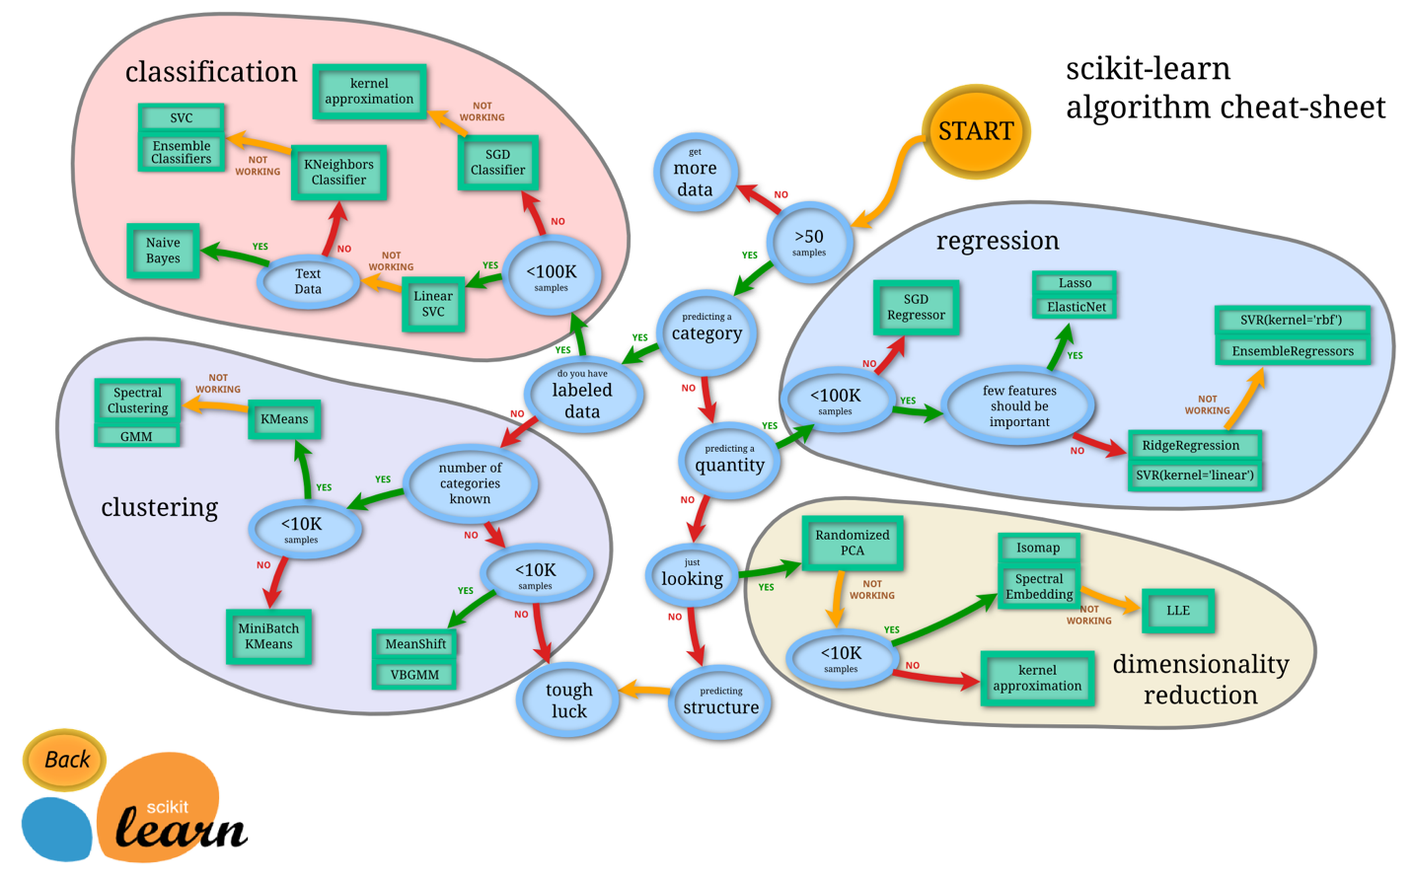

**————— o —————**

**Module 14**

**Decision Trees**

1. Build a decision tree manually
2. Train a decision tree model with desired hyperparameters using scikit-learn
3. Visualize a decision tree
4. Evaluate overfitting of decision trees
5. Evaluate decision tree splits
6. Implement the decision tree algorithm
7. Compare the performance of different grid search algorithms

* [Video Transcripts](https://student.emeritus.org/courses/4765/files/3353899?wrap=1)
* [Download Video Transcripts](https://student.emeritus.org/courses/4765/files/3353899/download?download_frd=1)
* [Quick Reference Guide](https://student.emeritus.org/courses/4765/files/3353900?wrap=1)

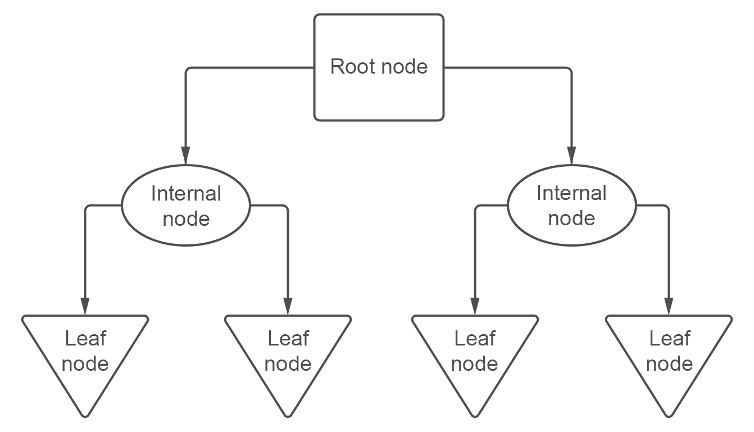

**Notes:**

Glossary

**Branch**

A connection between nodes

**Entropy**

The degree of impurity or uncertainty in a set of observations

**Internal Node**

A node that has two or more branches and can be split further

**Leaf Node**

A node that can no longer be split

**Pruning**

A set of techniques to ‘trim’ branches from the decision tree, making the tree faster to compute

**Root Node**

The beginning node of a decision tree

**Weighted Entropy**

The entropy of a node multiplied by the fraction of samples in that node

X2 = X[['flipper_length_mm', 'bill_length_mm']]

dtree = DecisionTreeClassifier(max_depth = 2).fit(X2, y)

tree2 = export_text(dtree, feature_names = list(X2.columns))

### ANSWER CHECK

print(tree2)

sns.scatterplot(data=X2, x='flipper_length_mm', y='bill_length_mm', hue=y)

plt.axvline(x=206.50, color="black")

plt.axhline(y=43.35, xmin=0, xmax=0.575, color="black")

plt.axhline(y=40.85, xmin=0.575, xmax=1, color="black")

dtree3 = DecisionTreeClassifier(max_depth = 3).fit(X2, y)

tree3 = export_text(dtree3, feature_names = list(X2.columns))

prediction = dtree3.predict(pd.DataFrame([[209, 41.2]], columns=X2.columns))

import ssl

ssl._create_default_https_context = ssl._create_unverified_context

**Module Issues:**

Codio 14.4 Problem 4: must to declare those variables:

**ent_age1 = -(1 * np.log2(1))**

**ent_age2 = -(1/4 * np.log2(1/4) + 3/4 * np.log2(3/4))**

Codio 14.4 Problem 5: parameter should be **criterion = 'entropy'**

Codio 14.6 Problem 3: Do not include the last element in ccp_alphas in the for loop: **for i in ccp_alphas[:-1]**

Codio 14.6 Problem 4: Change to **plt.step(ccp_alphas, depths, '--o')**

Codio 14.6 marked as Codio 14.7 in the activity.

**Quizes:**

A decision tree is a tree of questions that should be answered arbitrarily to yield a predictive classification. : False

*You are correct! The answer “*False*” is correct because a decision tree is a tree of questions that should be answered in sequence to yield a predictive classification.*

The decision boundaries of a logistic regression model are linear. : True

*You are correct! The answer “*True*” is correct because the decision boundaries of a logistic regression model are linear.*

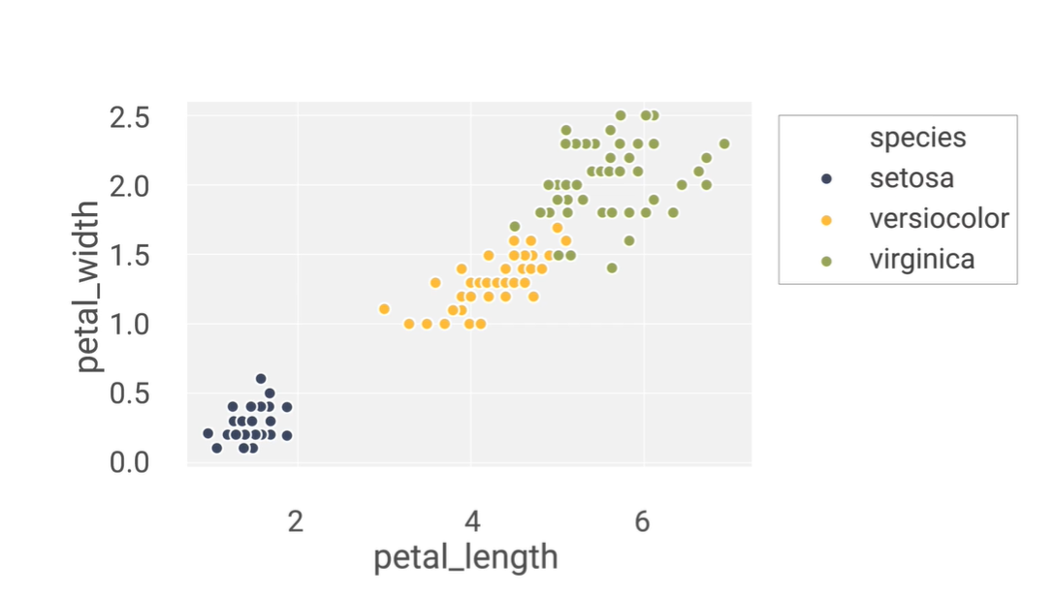

Consider this plot with petal_length on the x-axis and petal_width on the y-axis. For a decision rule “petal_width < 0.75 and petal_length < 2” equal to yes, what class would be chosen? : setosa

*You are correct! The answer “*setosa*” is correct because in this range of decision rules, setosa is the only class present, thus making setosa the best prediction.*

What is the correct Python statement to import a decision tree model from scikit-learn? : from sklearn import tree

*You are correct! The answer “*from sklearn import tree*” is correct because this is the correct Python statement to import decision tree models from scikit-learn.*

“d_t=tree.DecisionTree(criterion=’entropy’)”

The given Python code is the correct code for building a decision tree classifier. : False

*You are correct! The answer “*False*” is correct because the correct function for building a decision tree classifier is* *“*DecisionTreeClassifier(criterion=’entropy’)*”.*

Which of the following is not a constructor used in “tree.plot_tree()” function? : criterion

*You are correct! The answer “*criterion*” is correct because this is the constructor of the “*DecisionTreeClassifier()*” not for “*plot_tree()” *function.*

Seaborn is the best library to visualize a decision tree. : False

*You are correct! The answer “*False*” is correct because the Python library used to visualize the decision tree plot with better layout is Graphviz.*

A node from a decision tree

|  |
| --- |
| petal_width ≤ 1.75 |
| entropy = 1.0 |
| samples = 100 |
| value = [0, 50, 50] |
| class = versicolor |

Given a single node of a decision tree built with class_names=[“a”,“b”,“c”], how many samples belong to class “a” at this node? : 0

*You are correct! The answer “*0*” is correct because the parameter ‘value’ at the specific node tells the number of samples belonging to each class. Since there are three classes (“*a*”, “*b*”, and “*c*”) and the ‘value’ parameter here says [0, 50, 50], that means there are 0 samples in class “*a*” (and 50 each in “*b*” and “*c*”).*

What is the correct Python function that can be used to measure the accuracy of a decision tree classifier? : accuracy_score(predictions,original_data)

*You are correct! The answer “*accuracy_score(predictions,original_data)*” is correct because this is the correct Python function used to measure the accuracy of a decision tree classifier.*

Scikit-learn decision trees always have perfect accuracy on the training data, except when there are samples from the same classes with the exact same features. : False

*You are correct! The answer “*False*” is correct because scikit-learn decision trees always have perfect accuracy on the training data except when there are samples from different classes with the exact same features.*

The training accuracy for a decision tree classifier can be 100% when the data points overlap exactly. : False

*You are correct! The answer “*False*” is correct because the training accuracy for a decision tree classifier can be 100% when the data points do not overlap exactly.*

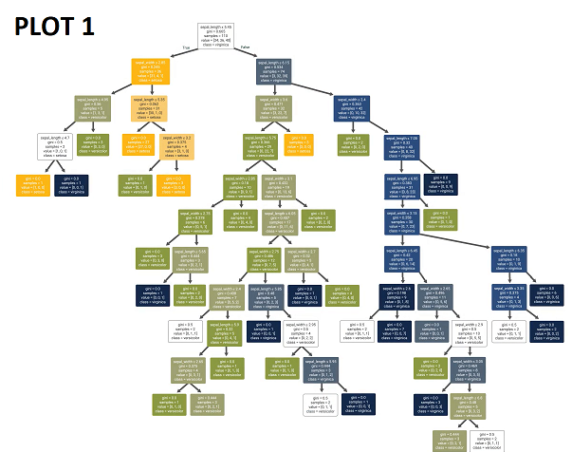

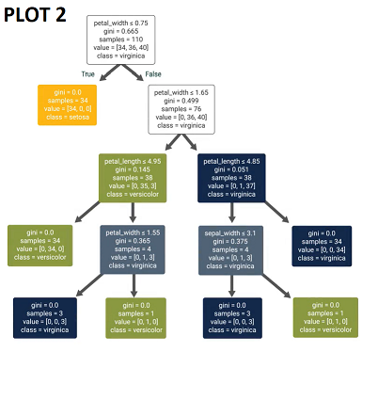

Consider the two decision trees above. Which of the plots seems to show overfitting? : Plot 1

*You are correct! The answer “*Plot 1*” is correct because it is highly complex, and the more complex the plot, the higher the chance of overfitting. Plot 1 seems to be more complex with more chances of overfitting.*

For decision tree classifiers, more features do not necessarily lead to overfitting. : True

*You are correct! The answer “*True*” is correct because more features do not lead to overfitting but can help in resolving the difference between the classes.*

The very first node of a decision tree is known as the leaf node. : False

*You are correct! The answer “*False*” is correct because the very first node of a decision tree is known as the root node.*

In the decision tree algorithm, after selecting the best feature “x” and the best split value “β”, the data is split into two nodes. One of the nodes has a rule where x < β. What is the rule for the other node? : x >= β

*You are correct! The answer “*x >= β*” is correct because after selecting “x” and “*β”,*the data is split into two nodes, one where x < β and one where*x >= β.

A node in a decision tree that has overlapping data points from different classes and thus cannot be split is called a “pure” node. : False

*You are correct! The answer “*False*” is correct because a node in the decision tree that has overlapping data points from different classes and thus cannot be split is called an ‘unsplittable’ node*.

A node from a decision tree

|  |
| --- |
| sepal_length ≤ 5.45 |
| gini = 0.665 |
| samples = 110 |
| value = [24, 36, 40] |
| class = virginica |

For this given node of a decision tree classifier, what would the value of “p2” be? : 0.36

*You are correct! The answer “*0.36*” is correct because p2 would be calculated as 40/110 which comes out to be “0.36”.*

What is the entropy (S) for a node with p values of [“p0=0.31”, “p1=0.33”, “p2=0.36”]? : 1.58

*You are correct! The answer “*1.58*” is correct because with the given values, the formula for entropy gives*

*−0.31 log2 0.31 − 0.33 log2 0.33 − 0.36 log2 0.36, which comes out to be 1.58.*

A node in a decision tree where data is evenly split between two classes has entropy 1. : True

*You are correct! The answer “*True*” is correct because with evenly split data for two classes, the formula for entropy is*

*−0.5 log2 0.5 − 0.5 log2 0.5, which is equal to 1.*

The weighted entropy (WS) of a node is its entropy scaled by the fraction of samples in that node. : True

*You are correct! The answer “*True*” is correct because the weighted entropy (WS) of a node is its entropy multiplied by the fraction of samples in that node divided by the total samples.*

The weighted entropy of the root node is equal to its entropy. : True

*You are correct! The answer “*True*” is correct because the weighted entropy is given as the entropy multiplied by the fraction of samples in that node, and the root node's fraction is 1 (n/n). Therefore, the entropy and the weighted entropy of the root node will always be the same.*

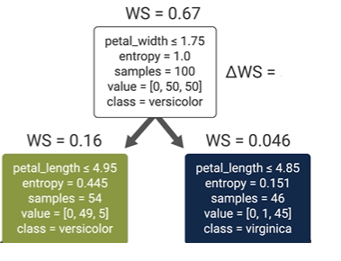

From the given information, what would ΔWS be for the root node? : 0.46

*You are correct! The answer “*0.46*” is correct because the ΔWS is given as the WS of the node minus the WS of the child nodes, which is 0.67 − (0.16 + 0.046) = 0.46.*

The decision tree classifier chooses the best feature and the best split such that the ΔWS is minimized. : False

*You are correct! The answer “*False*” is correct because the decision tree classifier chooses the best feature and the best split such that the ΔWS is maximized.*

The decision tree classifier can use L1 and L2 regularization. : False

*You are correct! The answer “*False*” is correct because decision trees do not have parameters that act as weights, so the algorithm cannot use L1 or L2 regularization.*

The default option for min_samples_split is two. : True

*You are correct! The answer “*True*” is correct because the default option for min_samples_split is 2.*

**Quiz Problems:**

Wrong answers set in the template for 4 questions, please see the attachments and correct the answer template as well as my grade. Thanks.

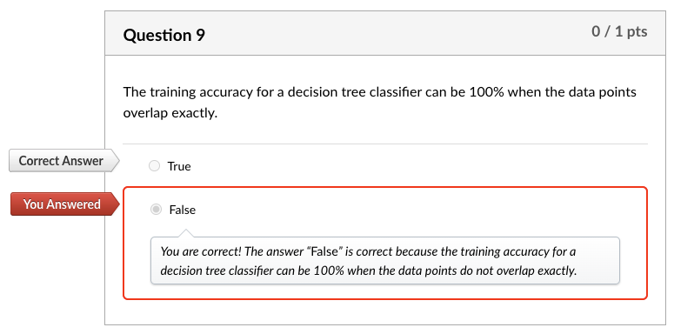

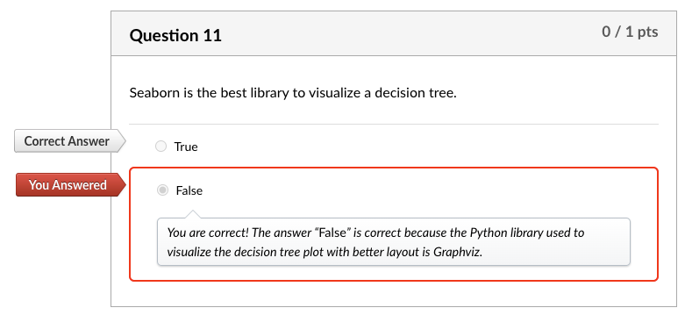

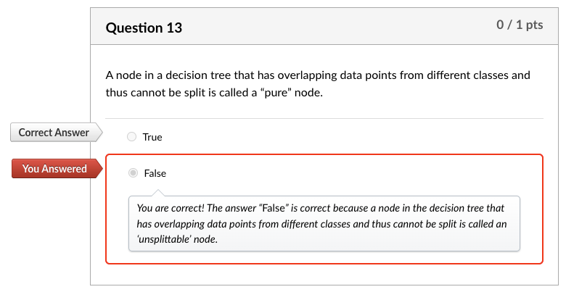

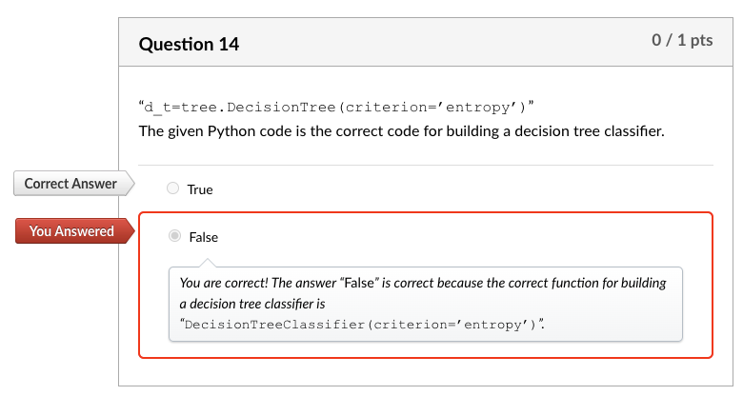

**Discussion 14.1: You Already Use Decision Trees**

Decision Tree for enjoying a (state) park visit

Do you want to visit a close by park?

Yes No

| |

Do you want to see peacocks? Do you want to drive less than 3 hours?

Yes No Yes No

| | | |

Go to Mayfield Park and Nature Preserve Emma Long Metropolitan Park Blue hole Park

How far you want to drive?

Do you want to drive less than 2 hours?

**Yes**

Do you want amenities and restaurants

Yes : Muller Park

Do you want to exercise but still in downtown?

Yes: Lady Bird Lake @ Cesar Chavez

No: McKinney Falls

**No:**

Do you want to stay in close proximity of a downtown?

Yes: Blue Hole Regional Park

No:

My decision tree is for choosing a park for recreational activities, sometimes I go restaurants after those places, other times just hiking, sometimes we do some country side driving. This is a simple decision tree what I want to do that day, yellow is close by parks, green is moderate drive, red is farther park:

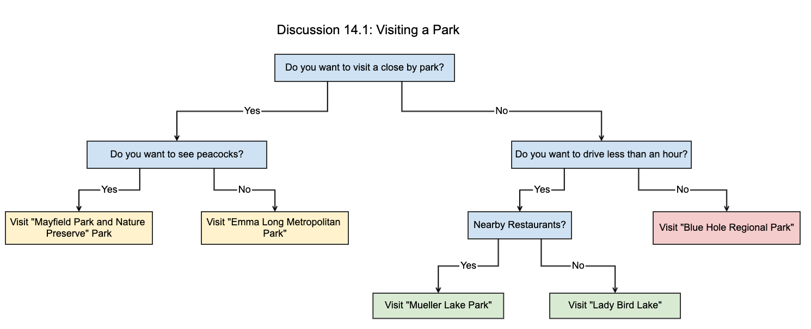

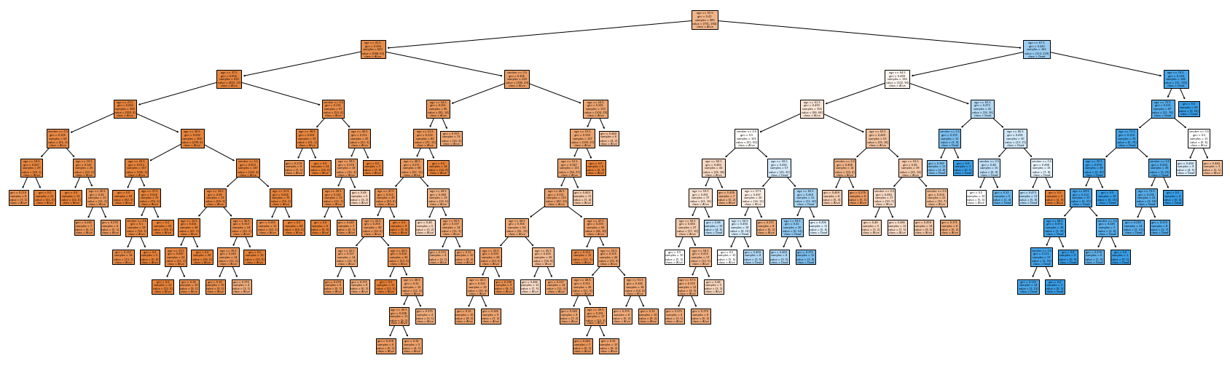

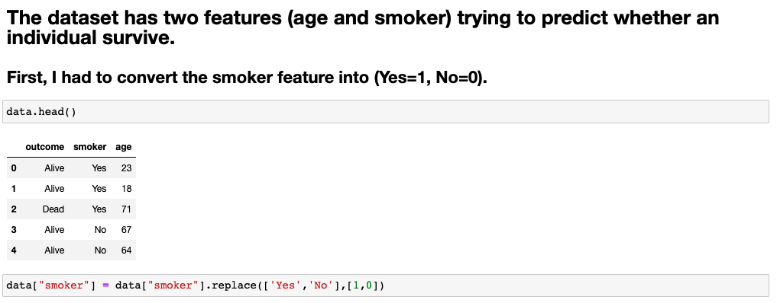

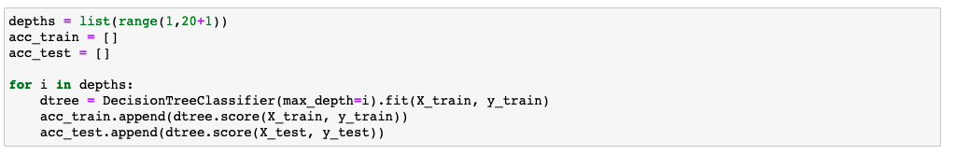

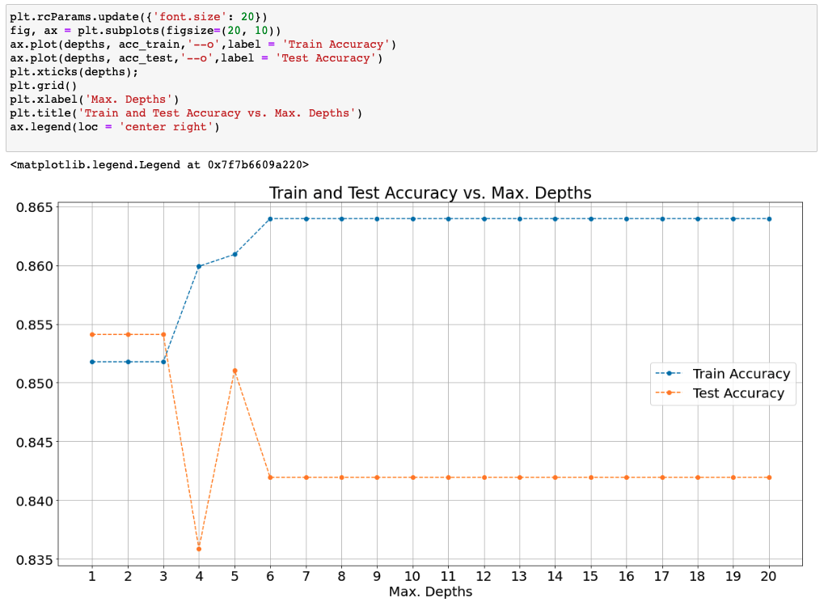

**Try-It Activity 14.1: Generating Overfit Models - Section B**

**Dataset Analysis**

Before iterating through depths until the maximum, I analyzed the dataset. Here is my findings about it:

There are no null values, 1314 entries, 2 string columns.

**Feature Overlapping**

I got curious about feature overlapping for different classes, sure enough there are 72 feature overlapping cases affecting ~11% of the entire population, or model cannot perform for those:

# number of overlapping feature with different classes

data_size = data.groupby(['smoker', 'age', 'outcome']).size().groupby(['smoker', 'age']).size().reset_index()

data_size[data_size[0]>1]

**Data Preparation**

The rest is transforming smoker column to integer 1/0 binary values, checking if the dataset is balanced, it is 72% and 28% distribution per outcome target column.

y.value_counts(normalize=True)

**Maximum Depth for Upper Bound**

I ran a default model to get maximum depth for upper bound:

# get maximum depth with default parameters:

max_tree = DecisionTreeClassifier(random_state=93).fit(X_train, y_train)

max_depth = max_tree.get_depth()

**Iteration for Depth**

Iterating the model over while incrementing the max_depth parameter to analyze overfitting

# Try out all depths to capture scores

train_accs = []

test_accs = []

for d in range(1,max_depth+1,1):

#create decision tree and fit it

tree = DecisionTreeClassifier(random_state=93, max_depth=d).fit(X_train, y_train)

# populate train and test accuracy lists

train_accs.append(tree.score(X_train, y_train))

test_accs.append(tree.score(X_test, y_test))

**Accuracy Scores**

# plot scores

plt.subplots(figsize = (10, 7))

plt.step(range(1,max_depth+1,1), train_accs, '-o', label = 'Train')

plt.step(range(1,max_depth+1,1), test_accs, '-o', label = 'Test')

plt.plot(np.argmax(test_accs)+1, max(test_accs), 'ro', markersize = 12, alpha = 0.4, label = 'Best Score')

plt.xticks(range(1,max_depth+1,1), rotation = 0)

plt.legend()

plt.grid()

plt.xlabel('Tree Depth')

plt.ylabel('Score')

plt.title('Tree Depth vs. Train/Test Scores', fontsize=14)

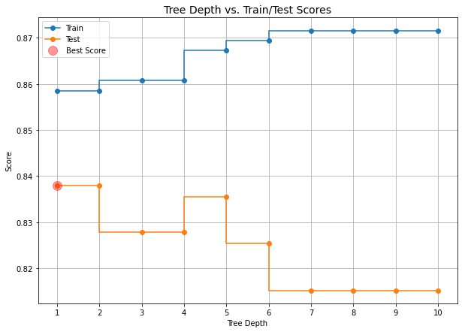

Overfitting begins after max_depth=1 in this case as test scores decreasing. Please note, depth=1 and 2 scores are the same.

**Optimum Tree:**

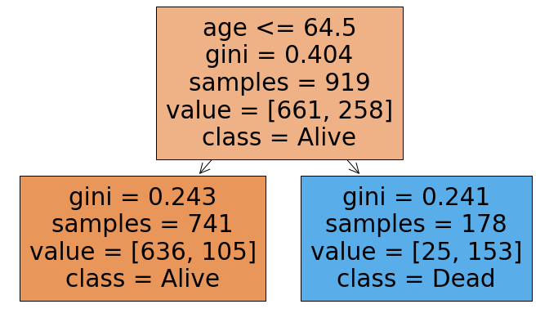

**Maximum Depth Tree:**

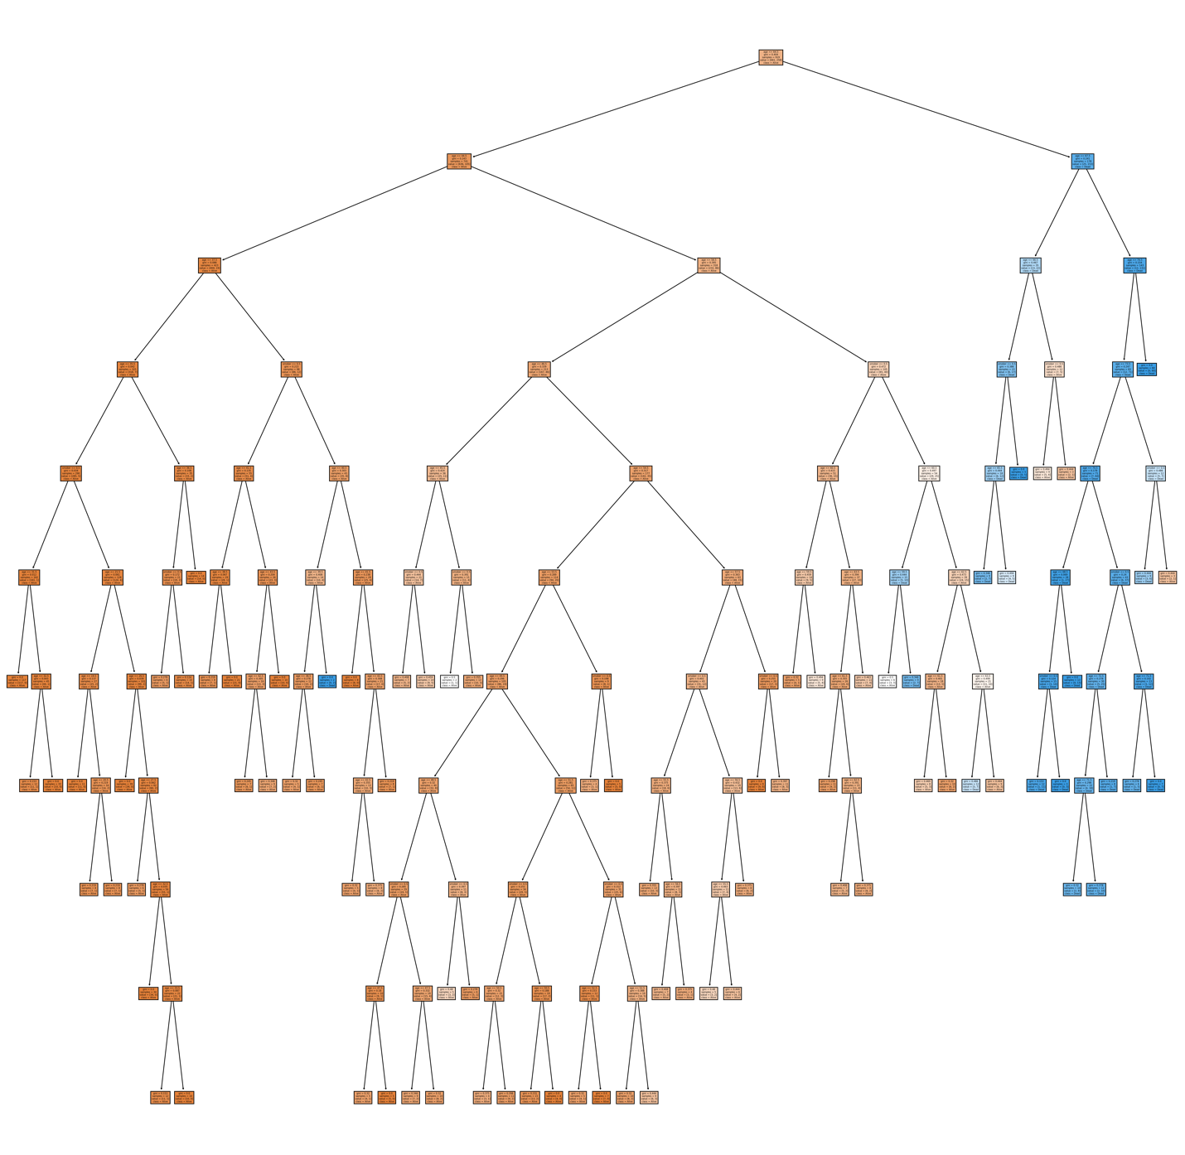

**Conclusion**

Best accuracy score is an indicator we can spot where overfitting begins on the plot per test accuracy scores. The score degraded when increasing the tree depth, the best score is about 84%, I computed the feature overlapping as 11% which may yield false classification, the best we can get from the model is 89% anyway. In contrast to that, the train accuracy increases with tree-depth increase which is another sign of overfitting.

**Try-It Activity 14.2: Grid Searching Decision Trees - Section B**

I used the same dataset we used in the previous try-t activity. Same analysis, data is imbalanced 72% and 28% distribution per *outcome* target column, 72 feature overlapping, etc.

**Parameters for Grid Search**

# Put some values to try out

params = {'max_depth': [2, 3, 4, 5, 6, 7, 10],

'min_samples_split': [0.1, 0.2, 0.05],

'criterion': ['gini', 'entropy'],

'min_samples_leaf': [2, 3, 4, 5]

}

**Model**

# initialize

dtree = DecisionTreeClassifier(random_state=93)

**Comparing Grid Searches**

I built 4 grid search for:

* GridSearchCV
* RandomizedSearchCV
* HalvingGridSearchCV
* HalvingRandomSearchCV

# GridSearchCV

grid = GridSearchCV(dtree, param_grid=params).fit(X_train, y_train)

grid_train_acc = grid.score(X_train, y_train)

grid_test_acc = grid.score(X_test, y_test)

best_params = grid.best_params_

### Results

print(f'Training Accuracy: {grid_train_acc: .2f}')

print(f'Test Accuracy : {grid_test_acc: .8f}')

print(f'Best parameters of tree: {best_params}')

Training Accuracy: 0.86

Test Accuracy : 0.83797468

Best parameters of tree: {'criterion': 'gini', 'max_depth': 2, 'min_samples_leaf': 2, 'min_samples_split': 0.1}

# RandomizedSearchCV

rgrid = RandomizedSearchCV(dtree, param_distributions=params).fit(X_train, y_train)

rgrid_train_acc = rgrid.score(X_train, y_train)

rgrid_test_acc = rgrid.score(X_test, y_test)

rbest_params = rgrid.best_params_

### Results

print(f'Training Accuracy: {rgrid_train_acc: .2f}')

print(f'Test Accuracy : {rgrid_test_acc: .8f}')

print(f'Best parameters of tree: {rbest_params}')

Training Accuracy: 0.86

Test Accuracy : 0.83797468

Best parameters of tree: {'min_samples_split': 0.2, 'min_samples_leaf': 2, 'max_depth': 7, 'criterion': 'gini'}

# HalvingGridSearchCV

hgrid = HalvingGridSearchCV(dtree, param_grid=params).fit(X_train, y_train)

hgrid_train_acc = hgrid.score(X_train, y_train)

hgrid_test_acc = hgrid.score(X_test, y_test)

hbest_params = hgrid.best_params_

### Results

print(f'Training Accuracy: {hgrid_train_acc: .2f}')

print(f'Test Accuracy : {hgrid_test_acc: .8f}')

print(f'Best parameters of tree: {hbest_params}')

Training Accuracy: 0.86

Test Accuracy : 0.83797468

Best parameters of tree: {'criterion': 'entropy', 'max_depth': 3, 'min_samples_leaf': 4, 'min_samples_split': 0.05}

# HalvingRandomSearchCV

hrgrid = HalvingRandomSearchCV(dtree, param_distributions=params).fit(X_train, y_train)

hrgrid_train_acc = hrgrid.score(X_train, y_train)

hrgrid_test_acc = hrgrid.score(X_test, y_test)

hrbest_params = hrgrid.best_params_

### Results

print(f'Training Accuracy: {hrgrid_train_acc: .2f}')

print(f'Test Accuracy : {hrgrid_test_acc: .8f}')

print(f'Best parameters of tree: {hrbest_params}')

Training Accuracy: 0.86

Test Accuracy : 0.83797468

Best parameters of tree: {'min_samples_split': 0.1, 'min_samples_leaf': 3, 'max_depth': 2, 'criterion': 'gini'}

Their train and test accuracy scores came out the same for all execution results but each search method picked different best parameters.

I used *mean_fit_time* in cv_results_ to computed cumulated elapsed time for the plots when I need time comparison among all:

# Time spent

# set metrics!

grid_options=['GridSearchCV','RandomizedSearchCV','HalvingGridSearchCV','HalvingRandomSearchCV']

train_accs = [grid_train_acc, rgrid_train_acc, hgrid_train_acc, hrgrid_train_acc]

test_accs = [grid_test_acc, rgrid_test_acc, hgrid_test_acc, hrgrid_test_acc]

elapsed_times = [np.sum(grid.cv_results_['mean_fit_time']), np.sum(rgrid.cv_results_['mean_fit_time']),

np.sum(hgrid.cv_results_['mean_fit_time']), np.sum(hrgrid.cv_results_['mean_fit_time'])]

depths = [best_params['max_depth'], rbest_params['max_depth'], hbest_params['max_depth'], hrbest_params['max_depth']]

splits = [best_params['min_samples_split'], rbest_params['min_samples_split'],

hbest_params['min_samples_split'], hrbest_params['min_samples_split']]

leaves = [best_params['min_samples_leaf'], rbest_params['min_samples_leaf'],

hbest_params['min_samples_leaf'], hrbest_params['min_samples_leaf']]

# plot accuracy and time elapsed

fig, ax = plt.subplots(1, 2, figsize = (15, 8))

ax[0].plot(grid_options, train_accs, '--o', label = 'Training Accuracy')

ax[0].plot(grid_options, test_accs, '--o', label = 'Testing Accuracy')

ax[0].plot(grid_options, [max(test_accs)]*len(grid_options), 'ro', markersize = 12, alpha = 0.4, label = 'Best Score')

ax[0].tick_params(axis='x', rotation=90)

ax[0].set_xlabel('Grid Search Options')

ax[0].set_ylabel('Accuracy Score')

ax[0].set_title('Grid Search Options vs. Accuracy Score all is best')

ax[0].legend()

# time plot

ax[1].plot(grid_options, elapsed_times, '--o', label = 'Elapsed Time')

ax[1].tick_params(axis='x', rotation=90)

ax[1].set_xlabel('Grid Search Options')

ax[1].set_ylabel('Cumulative Elapsed Time')

ax[1].set_title(f'Grid Search Options vs. Elapsed Time best @ {grid_options[np.argmin(elapsed_times)]}')

ax[1].plot(np.argmin(elapsed_times), min(elapsed_times), 'ro', markersize = 12, alpha = 0.4, label = 'Best Time')

ax[1].legend()

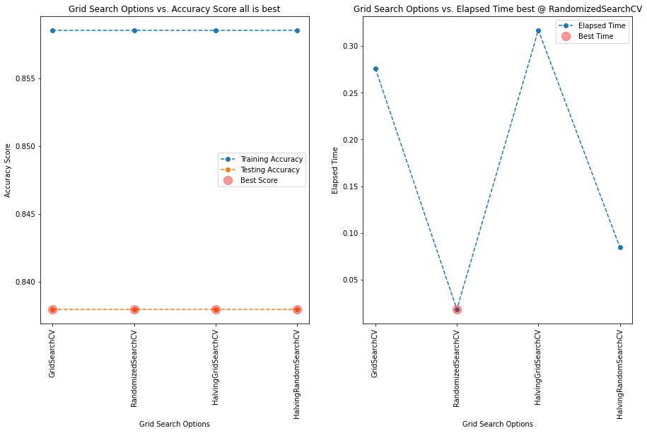

Consensus on all methods for best score, however, RandomizedSearchCV is winner in elapsed time! However, GridSearchCV and HalvingGridSearchCV are significantly higher cumulative times than RandomizedSearchCV and HalvingRandomSearchCV.

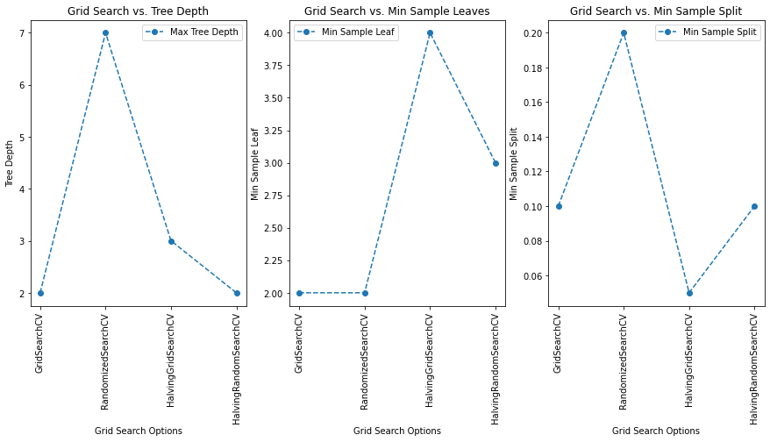

Best max_depth=2, two methods GridSearchCV and HalvingRandomSearchCV achieved it. Best min_samples_leaf=2, by GridSearchCV and RandomizedSearchCV. Best min_samples_split=0.05 by HalvingGridSearchCV.

**Conclusion**

Best parameters from GridSearchCV and HalvingRandomSearchCV have the minimum max_depth=2 which reduces complexity.

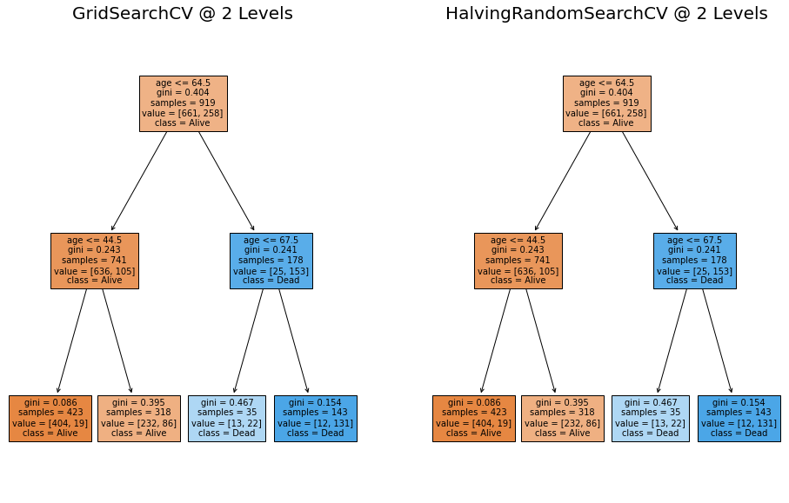

Also, the other best parameters are the same {'min_samples_split': 0.1, 'max_depth': 2, 'criterion': 'gini'} except 'min_samples_leaf': 3 by HalvingRandomSearchCV and 'min_samples_leaf': 2 by GridSearchCV.

Both produced the exact same decision tree but HalvingRandomSearchCV is more than 3 times faster than GridSearchCV.

Miguel:

n_splits  = tree_grid_1.n_splits_

n_iter = pd.DataFrame(tree_grid_1.cv_results_).shape[0]

mean_time=np.mean(tree_grid_1.cv_results_['mean_fit_time'] + tree_grid_1.cv_results_['mean_score_time'])

print(f'Elapsed Time using RandomizedSearchCV: {mean_time * n_splits * n_iter: .3f}')

 ————— o —————

**Module 15**

**Gradient Descent and Optimization**

1. Compute x and/or y for each iteration of gradient descent
2. Explain how learning rate and starting guess affect the convergence of gradient descent
3. Optimize a single-parameter linear regression model from scratch
4. Recognize convex one-dimensional and two-dimensional functions
5. Compute the gradient of a two-dimensional function
6. Use gradient descent to optimize a nonlinear two-dimensional regression model
7. Use stochastic gradient descent to optimize a nonlinear two-dimensional regression model
8. Compare the convergence behavior of gradient descent with stochastic gradient descent
9. Identify the degrees of bias and variance in a model
10. Identify the relationship between bias, variance, and model complexity

* [Video Transcripts](https://student.emeritus.org/courses/4765/files/3390438?wrap=1)
* [Download Video Transcripts](https://student.emeritus.org/courses/4765/files/3390438/download?download_frd=1)
* [Quick Reference Guide](https://student.emeritus.org/courses/4765/files/3390449?wrap=1)

**Program learning outcomes addressed this module:**

* Apply real-world tools to model and analyze real-world data
* Communicate foundational concepts about AI/ML
* Draw useful conclusions from real-world data
* Identify the best ML model to solve a problem (Models: Classification, regression, time series analysis)

**Optimizing Linear Regression**

As previously discussed, linear regression assumes only one independent variable and a linear relationship between the independent (X) and dependent (Y) variables.Linear regression determines the relationship between the two variables by fitting a linear equation to the observed data. The best fit can be defined by the hypothesis equation, where w0 and w1 are weighted so that they are optimized to fit the best line and reduce cost (loss). Two primary methods are used to minimize the cost: Gradient descent and normal equation. Gradient descent can find the value of w0 and w1 using an iterative process to minimize the overall cost. In contrast, normal equation can find the weights (w) for which the cost is minimal.

**The Bias–Variance Tradeoff**

Prediction errors can be broken down into two main subcomponents: bias and variance. Bias and variance are key parameters that need to be tuned while training a machine learning model.

**Bias Error**

A bias error is the difference between a model’s predictions and the actual value. In this type of error, the model ignores training data and oversimplifies the model without learning the patterns.

**Variance Error**

A model’s ability to predict a given data point or value tells you how widely your data is spread. During this type of error, the model pays a lot of attention to training data, to the point that it memorizes the data rather than learning from it. As a result, models with a high variance error have difficulty generalizing on unseen data.

The bias–variance tradeoff describes the tension between bias-introduced and variance-introduced errors.

**Glossary**

**Bias Error**

The difference between a model’s predictions and the actual values

**Convexity**

A measure of the curvature, or the degree of the curve, where a line drawn between two points will have all points between the two endpoints under the line

**Gradient Descent**

An algorithm used to find a local minimum/maximum of a given function

**Stochastic Gradient Descent**

A technique that is an approximation of gradient descent

**Variance Error**

A model’s ability to predict a given data point or value that tells you how widely the data is spread

Gradient Descent is used in Liner Regression models, not for any other methodology!

**Notes:**

**Batch gradient descent**, also known as vanilla gradient descent, calculates the errors for each example in the training dataset, but the model is only updated once all training examples have been evaluated. The whole process is referred to as a training epoch.

**Stochastic gradient descent (SGD**) updates the parameters for every training example in the dataset, meaning each example’s parameters are updated one at a time. In some cases, this can make SGD faster than batch gradient descent.

**Mini-batch gradient descent** is the preferred method because it combines the concepts of batch gradient descent and SGD. It splits the training dataset into small batches and updates each batch individually. A balance is thus created between the robustness of SGD and the efficiency of batch gradient descent.

convex aka concave up!

M = (y2 - y1) / (x2 - x1)

t1s = ex2.iloc[:, 1]

t0s = ex2.iloc[:, 0]

theta1 = np.linspace(0, 20, 100)

theta0 = np.linspace(0, 20, 100)

T0, T1 = np.meshgrid(theta0, theta1)

fig = plt.figure(figsize=(16, 6))

ax = fig.add_subplot(1, 2, 1, projection = '3d')

ax.plot3D(t0s, t1s, mse(t0s, t1s), '-->', color = 'red')

ax.plot_wireframe(T0, T1, mse(T0, T1), alpha = 0.2)

ax2 = fig.add_subplot(1, 2, 2)

ax2.contour(T0, T1, mse(T0, T1), levels = 30)

ax2.plot(t0s, t1s, mse(t0s, t1s), color = 'red')

ax2.set_xlim(0, 20)

ax2.set_ylim(0, 20)

**Module Issues:**

**Codio Activity 15.7 Problem 3**: Hidden Test uses *mse_grad* student solution!

***for*** *i* ***in*** *range(1000):*

*thetas_.append(theta_)*

*theta_ = theta_ - lr*mse_grad(theta_, X_, y)*

**Codio Activity 15.8** Plot broken projection = “3”d

**Codio Activity 15.9 Problem 2**: typo in print(***sgd_defaults***)

**Codio Activity 15.10** Reset option is not given



**End of Module Quiz Problems:**

The answer sheet template is wrong for a question, please see the attachment and correct the answer template as well as my grade. Thanks.

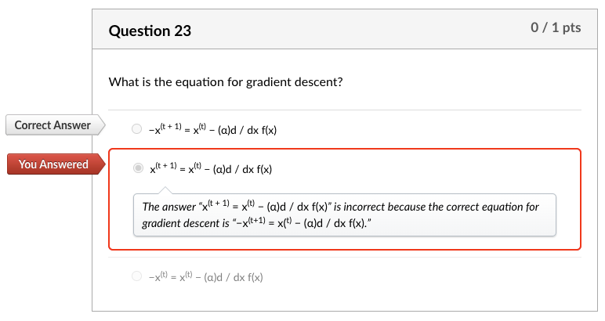

What is the equation for gradient descent?

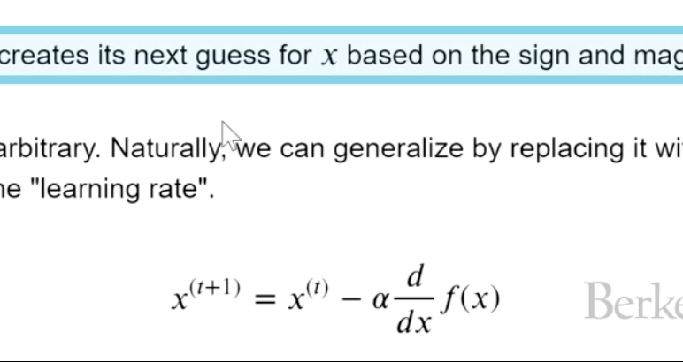

**Quizes:**

Gradient descent is a technique used to minimize functions. : True

*You are correct! The answer “*True*” is correct because the gradient descent (GD) is an iterative first-order optimization algorithm used to find a local minimum/maximum of a given function.*

Consider the following Python function:

minimize(arbitrary,x0)

What is the second constructor used as? : The starting point for the function to minimize

*You are correct! The answer “*The starting point for the function to minimize*” is correct because it represents the initial guess as the starting value to minimize the function.*

If the derivative of a function is negative, that means the function is (blank). : decreasing

*You are correct! The answer “*decreasing*” is correct because a function is decreasing if a derivative of that function is negative.*

In gradient descent, the point where there is a minima or maxima of the function is where the derivative is (blank). : zero

*You are correct! The answer “z*ero*” is correct because when the derivative of a function is zero that point is the minima or maxima of the function.*

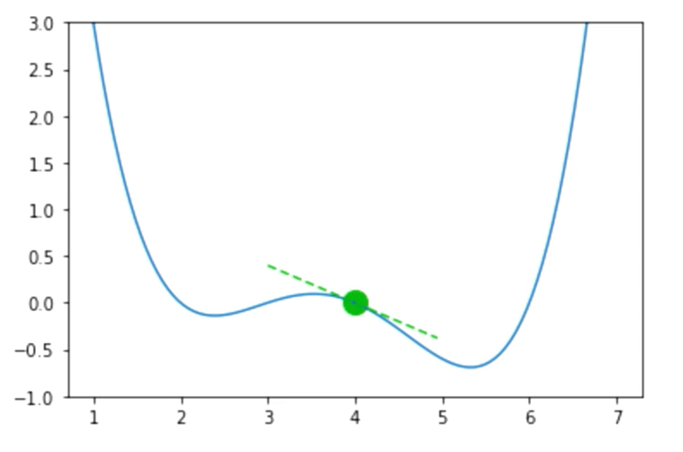

Given the above graph, suppose the guess for a function input is x = 4, f(x) = 0.0, and f’(x) = −0.4. Should you increase or decrease x for your next guess? : Increase

*You are correct! The answer “*Increase*” is correct because if the derivative of a function is negative, that means the function is decreasing, so you increase the x.*

What is the equation for gradient descent? : x(t + 1) = x(t) − (α)d / dx f(x)

*You are correct! The answer “*x(t + 1) = x(t) − (α)d / dx f(x)*” is correct because this is the equation for gradient descent.*

The value alpha (α) in the gradient descent function is known as learning rate. : True

*You are correct! The answer “*True*” is correct because it is known as the learning rate.*

The learning rate alpha (α) captures how quickly gradient descent learns the minimum. A small alpha moves slowly but has a high chance of overshooting. : False

*You are correct! The answer “*False*” is correct because a small alpha means small jumps toward the minimum, which have a lower chance of overshooting.*

Gradient descent always gives the global minimum. : False

*You are correct! The answer “*False*” is correct because if the function has a local minimum and the algorithm’s initial guess (which is the starting point) is close to the minimum, it can get stuck at the local minimum.*

The gradient descent is guaranteed to find the global minimum if the function has convexity. : True

*You are correct! The answer “*True*” is correct because the gradient descent is guaranteed to find the global minimum if the function has convexity.*

Under what circumstances is the loss function f said to be convex? : If a line is drawn between two points on a curve, all values on the curve must be on or below the line

*You are correct! The answer “*If a line is drawn between two points on a curve, all values on the curve must be on or below the line*” is correct because this is the condition for a function to be convex.*

Consider the following the graph:

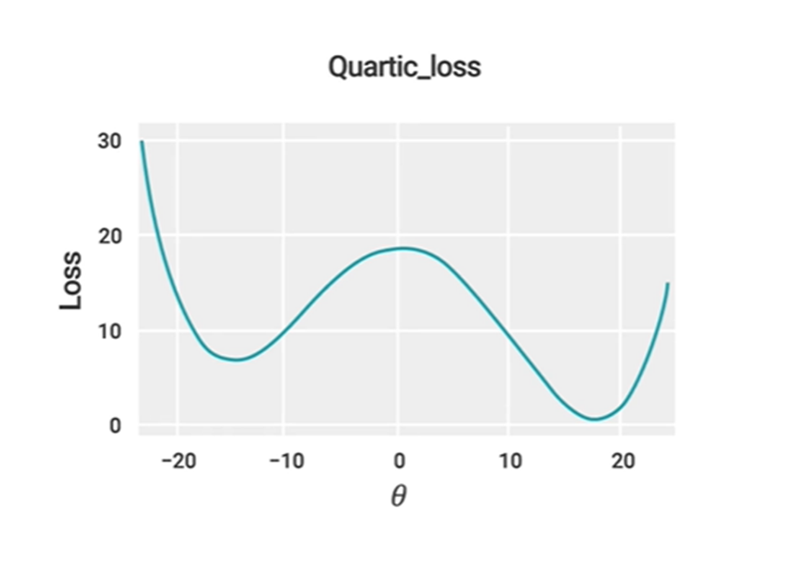

Is it convex or nonconvex? : Nonconvex

*You are correct! The answer “*Nonconvex*” is correct because the condition “if a line is drawn between two points on a curve, all values on the curve must be on or below the line” must be satisfied for a function to be convex. This plot does not satisfy this condition.*

Consider the following graph:

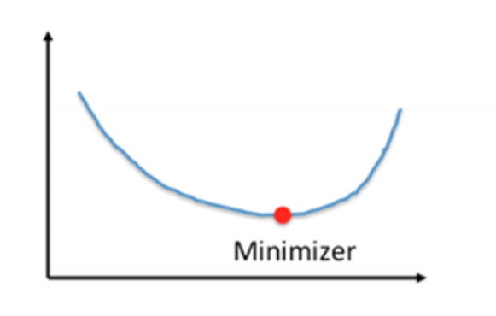

Is it convex or nonconvex? : Convex

*You are correct! The answer “C*onvex*” is correct because the condition “if a line is drawn between two points on a curve, all values on the curve must be on or below the line” must be satisfied for a function to be convex. This plot satisfies this condition.*

Consider the following graph:

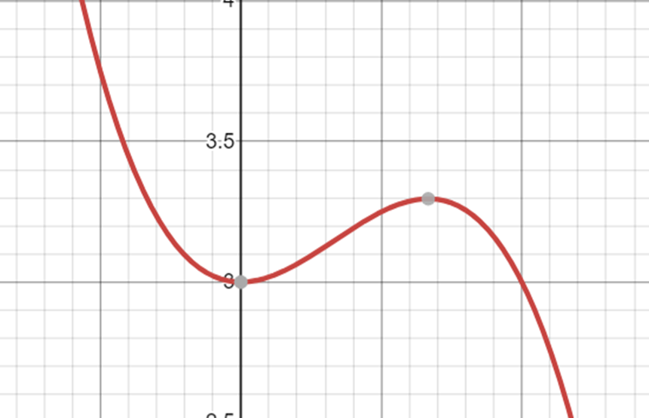

Is it convex or nonconvex?

*You are correct! The answer “*Nonconvex*” is correct because the condition “if a line is drawn between two points on a curve, all values on the curve must be on or below the line” must be satisfied for a function to be convex. This plot does not satisfy this condition.*

The function for mean squared error can be represented as mean((y_hat - y_obs)**2). : True

*You are correct! The answer “*True*” is correct because this is the function for mean squared error.*

For a model Tip = θ1 + θ2 * bill, the MSE loss function cannot be used to predict the optimal θ1 and θ2 values. : False

*You are correct! The answer “*False*” is correct because the MSE loss function can be used to predict the optimal θ1 and θ2 values.*

**def**mse_loss(theta, X, y_obs):     y_hat **=** theta[0] **\*** X.iloc[:, 0] **+** theta[1] **\*** X.iloc[:, 1]

*#can also write in matrix form:* *#y_hat = X @ theta*

**return**np.mean((y_hat **-** y_obs) **\*\*** 2)

From the function in the Python code block, determine the correct call statement for the function. : mse_loss(np.array([1,2]),X,y_obs)

*You are correct! The answer “*mse_loss(np.array([1,2]),X,y_obs)*” is correct because this is the correct function call statement.*

**def**mse_loss(theta, X, y_obs):     y_hat **=** theta[0] **\*** X.iloc[:, 0] **+** theta[1] **\*** X.iloc[:, 1]

*#can also write in matrix form:* *#y_hat = X @ theta*

**return**np.mean((y_hat **-** y_obs) **\*\*** 2)

From the function in the Python code block, determine the correct representation for a single argument function. : def mse_loss_single_arg(theta):

    X = tips_with_bias[["bias", "total_bill"]]

    y_obs = tips["tip"]

    return mse_loss(theta, X, y_obs)

*You are correct! The answer “*def mse_loss_single_arg(theta):

    X = tips_with_bias[["bias", "total_bill"]]

    y_obs = tips["tip"]

    return mse_loss(theta, X, y_obs)*” is correct because this is the correct representation for a single argument function.*

Given a function f(θ0,θ1) with two variables θ0 and θ1, what would the formula for the gradient of this 2D function be? : df / d(θ0)i + df / d(θ1)j

*You are correct! The answer “*df / d(θ0)i + df / d(θ1)j*” is correct because the gradient of the 2D function is a partial derivative with respect to variable one and a partial derivative with respect to variable two.*

To reduce the loss function, how should the θ values be adjusted? *Check all that apply.* : *“*Increase all values of θ that have a negative partial derivative*” and “*Decrease all values of θ that have a positive partial derivative.*”*

*You are correct! The answers “*Increase all values of θ that have a negative partial derivative*” and “*Decrease all values of θ that have a positive partial derivative*” are correct because these are the techniques to adjust the value of*θ *to reduce loss function.*

Consider the following two-dimensional linear regression model:

fθ→(x→)=(x→)Tθ→=θ0x0+θ1x1

What would the squared loss be for the single prediction of a linear regression model provided below? ℓ(θ→,x→,yi) : (yi − θ0x0 − θ1x1)2

*You are correct! The answer “(yi − θ0x0 − θ1x1)2” is correct because this is the correct representation of squared loss for a single prediction of a linear regression model.*(yi − θ0x0 − θ1x1)2

Consider the following two-dimensional linear regression model:

fθ→(x→)=(x→)Tθ→=θ0x0+θ1x1

The squared loss function is:ℓ(θ→,x→,yi)=(yi−θ0x0−θ1x1)2

What would the gradient formula of this loss function be? :

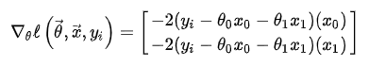

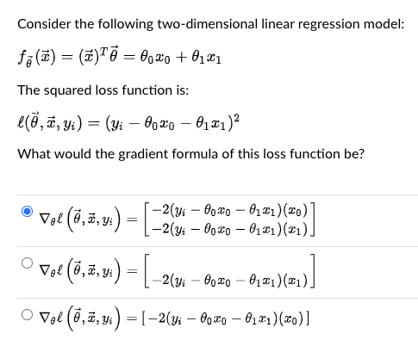

*You are correct! The answer “*

∇θℓ(θ→,x→,yi)=[

|  |
| --- |
| **−2(y**i**−θ**0**x**0**−θ**1**x**1**)(x**0**)** |
| **−2(y**i**−θ**0**x**0**−θ**1**x**1**)(x**1**)** |

]

*” is correct because this is the correct formula for the gradient of this loss function.*

Consider the given gradient formula:

∇θℓ(θ→,x→,yi)=[

|  |
| --- |
| **−2(y**i**−θ**0**x**0**−θ**1**x**1**)(x**0**)** |
| **−2(y**i**−θ**0**x**0**−θ**1**x**1**)(x**1**)** |

]



Is this the Python function to compute these gradient values?

**def** mse_gradient(theta, X, y_obs):     """Returns the gradient of the MSE on our data for the given theta"""     x0 = X.iloc[:, 0]     x1 = X.iloc[:, 1]     dth0 = np.mean(-2 **\*** (y_obs **-** theta[0]**\***x0 **-** theta[1]**\***x1) **\*** x0)     dth1 = np.mean(-2 **\*** (y_obs **-** theta[0]**\***x0 **-** theta[1]**\***x1) **\*** x1)     **return**np.array([dth0, dth1])

: True

*You are correct! The answer “*True*” is correct because this is the correct Python function to compute gradient values.*

Gradients are a function of the entire dataset. : True

*You are correct! The answer “*True*” is correct because a gradient’s function is applied to the entire dataset to get the gradient value.*

Consider the following function call in Python:

mse_gradient_batch_only(theta,batch_indices,X,y_obs)

What does the constructor “batch_indices” represent? : The list of indices of data to calculate loss

*You are correct! The answer “*The list of indices of data to calculate loss*” is correct because this is what “*batch_indices*” represents.*

The Python function np.split() is used to split an input array into a random number of subarrays. : False

*You are correct! The answer “*False*” is correct because the function*np.split()*is used to split an input array that is provided as a constructor to a function into a number of subarrays.*

Which of the following divides the entire dataset into a batch of datasets in order to save computing time? : Stochastic gradient descent

*You are correct! The answer “*Stochastic gradient descent*” is correct because stochastic gradient descent divides the entire dataset into a batch of datasets to save computing time.*

If the batch size is 1, the quality of the gradient is minimum, but the calculation is very fast. : True

*You are correct! The answer “*True*” is correct because the batch size is a parameter that gives the ability to tradeoff the quality of the gradient approximation against the runtime to compute the gradient approximation.*

In environments with large amounts of data, it is much more common to use mini-batch gradient descent. : True

*You are correct! The answer “*True*” is correct because the cost of computing the gradient on the entire dataset is too high, resulting in very slow algorithm training times.*

If the model is pushed to higher levels of complexity, thereby excessively increasing the parameters, the training error reduces to zero. : True

*You are correct! The answer “*True*” is correct because if the number of parameters is increased, the model is overparameterized, and there is an infinite number of valid choices of parameters that yield zero training errors.*

Overparameterized models that are trained with SGD act as if they are regularized. : True

*You are correct! The answer “*True*” is correct because overparameterized SGD results in a model that is implicitly regularized, yielding less wiggly behavior.*

Consider the following plots of two separate models:

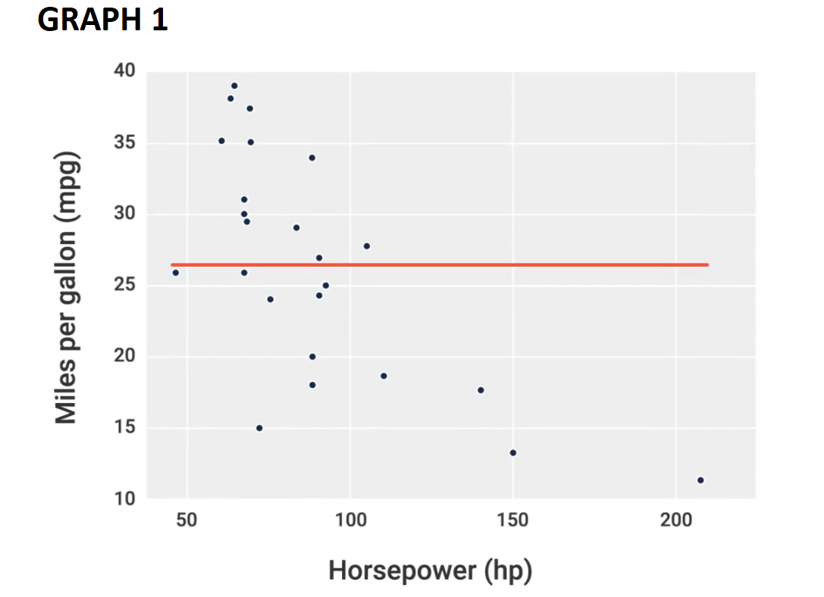

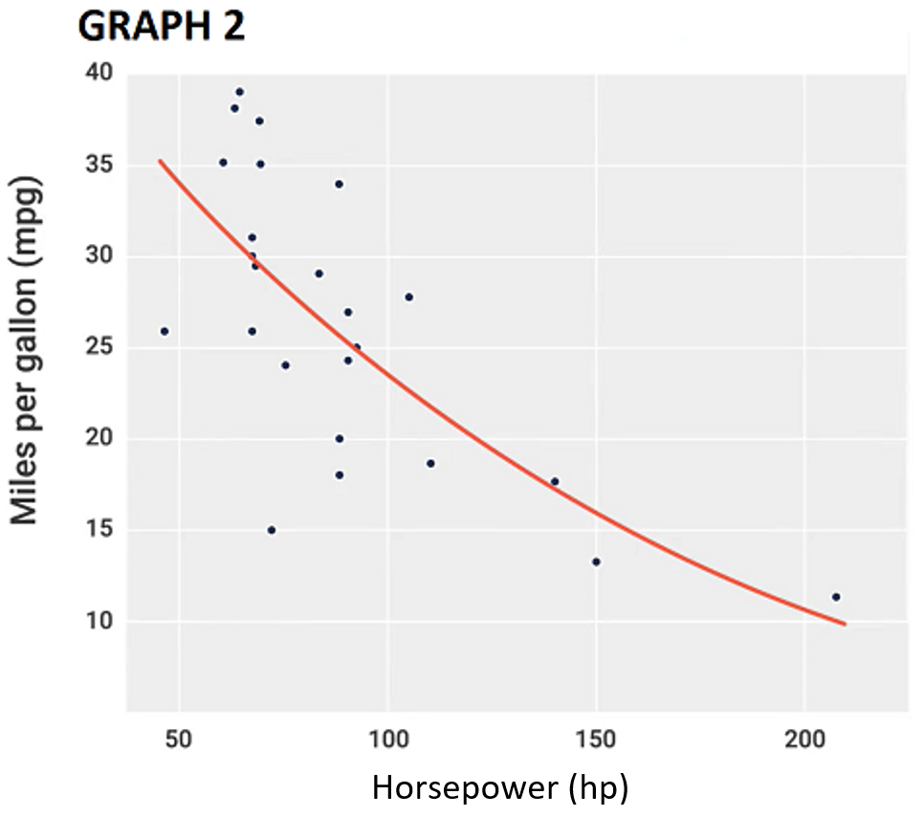

Which one has high bias? : Graph 1

*You are correct! The answer “*Graph 1*” is correct because the bias represents the fundamental inability of a model to fit the data, no matter what parameters are provided. Therefore, Graph 1 displays the inability to fit the model.*

Consider the following plots of two separate models:

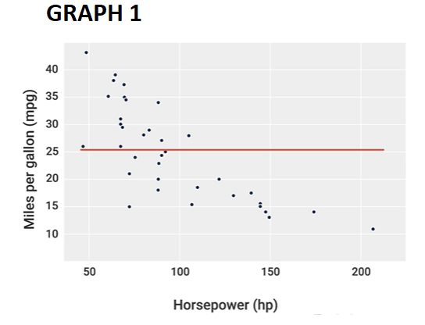

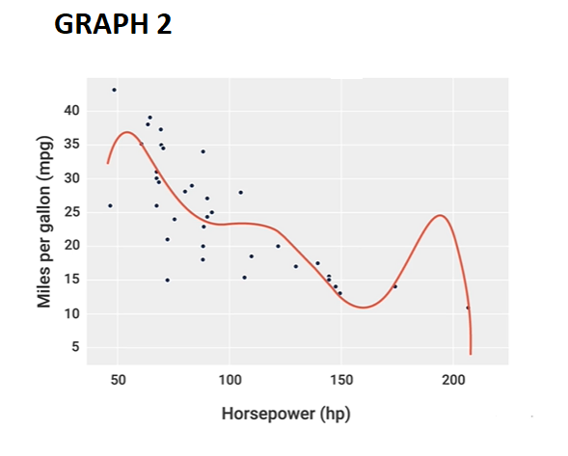

Which one has high variance? : Graph 2

*You are correct! The answer “*Graph 2*” is correct because variance represents how sensitive the model is to the data. Therefore, it can be seen that Graph 2 is more sensitive to the data.*

As the model complexity increases, the bias will increase, and the variance will tend to decrease. : False

*You are correct! The answer “*False*” is correct because as the model complexity increases, the bias will decrease, and the variance will tend to increase.*

 ————— o —————

**Module 16**

**Support Vector Machines (SVMs)**

* [Video Transcripts](https://student.emeritus.org/courses/4765/files/3406592?wrap=1)
* [Download Video Transcripts](https://student.emeritus.org/courses/4765/files/3406592/download?download_frd=1)
* [Quick Reference Guide](https://student.emeritus.org/courses/4765/files/3406595?wrap=1)

**Notes:**

**The Kernel Trick**

In machine learning, a kernel refers to a method of solving a nonlinear problem, using a linear classifier. This involves separating linearly inseparable data (Figure 1) from linearly separable data (Figure 2). In each data instance, a kernel function maps the original nonlinear observations to a higher-dimensional space that can be separated.

Now that you understand the kernel, the kernel trick will be easier to understand. The kernel trick allows you to find a decision surface that clearly differentiates between different classes if the data can be mapped from two-dimensional space to three-dimensional space. Then, as dimensional computations become more expensive within those spaces, the kernel can use the data in the original feature space without requiring coordinates in a higher-dimensional space.

**Maximum Margin Classifier**

An SVM creates two parallel hyperplanes that pass through the nearest data points. These nearest points are called support vectors, and the region between the support vectors is called the margin and is bounded by the two hyperplanes. These hyperplanes can be drawn in many different ways to classify the data. A hyperplane with the maximum margin is the most stable, and the margin indicates how far two classes are apart. In mathematics, the hyperplane with the highest margin is called the maximum margin hyperplane, and the classifier it defines is called the maximum margin classifier. Here is an illustration of the concept.

def make_plot(estimator):

xx = np.linspace(X1.iloc[:, 0].min(), X1.iloc[:, 0].max(), 50)

yy = np.linspace(X1.iloc[:, 1].min(), X1.iloc[:, 1].max(), 50)

XX, YY = np.meshgrid(xx, yy)

grid = np.c_[XX.ravel(), YY.ravel()]

labels = pd.factorize(estimator.predict(grid))[0]

plt.contourf(xx, yy, labels.reshape(XX.shape), cmap = 'twilight', alpha = 0.6)

sns.scatterplot(data = X1, x = 'total_phenols', y = 'color_intensity', hue = y, palette = 'flare')

**Module 16: Glossary**

**Hyperplane**

A flat subspace with dimension p − 1, given a p-dimensional space

**Kernel Trick**

A computational technique for enlarging the feature space

**Margin**

The distance between a hyperplane and the closest data point

**Maximum Margin Classifier**

A hyperplane whose margin is maximized

**Support Vectors**

Data points that are closer to the hyperplane and influence the position and orientation of the hyperplane

**Module Issues:**

**Codio Activity 16.1 Problem 1** ‘pipe’ is supposed to be ***lgr***

**Codio Activity 16.2 Problem 1 & 2** name 'scale' and 'model' in Pipeline for StandardScaler and KNeighborsClassifier respectively

**Codio Activity 16.2 Problem 2:** Make Variable **x to X** to make plot working!

* plt.plot(**x, lower(x)**, '--r')
* plt.plot(**x, upper(x)**, '--r')

**Codio Activity 16.9 Problem 1:** Make sure ***res_dict*** has the dictionary of your dataframe because the hidden test is using it!

**Quiz Issue:**

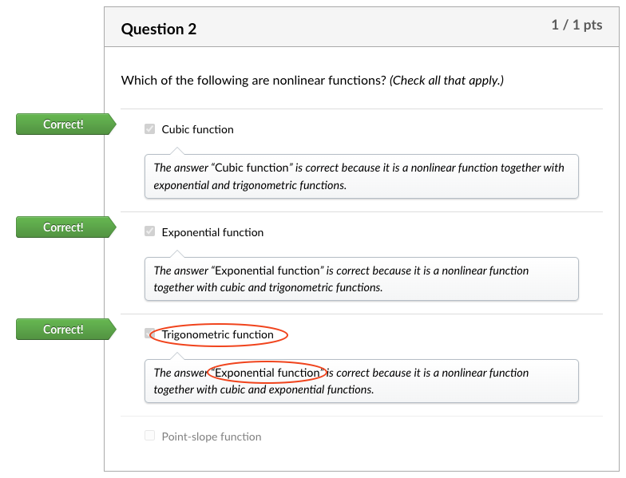

**Quizes:**

Which of the following is not the quadratic feature generated from x0 and x1 linear features? : x0x0

*You are correct! The answer “*x0x0*” is correct because the quadratic features generated from x0 and x1 are “*x0x1*”, “*x02”*, and “*x12*”.*

Nonlinear features are used to indicate the curvature and to classify a small portion of the data points. : False

*You are correct! The answer “*False*” is correct because nonlinear features are used to indicate the curvature and to classify large portions of the data points.*

Which of the following are nonlinear functions? *(Check all that apply.) :* Exponential function, Cubic function, Trigonometric function

*The answer “*Exponential function*” is correct because it is a nonlinear function together with cubic and trigonometric functions.*

*The answer “*Cubic function*” is correct because it is a nonlinear function together with exponential and trigonometric functions.*

*The answer “*Exponential function*” is correct because it is a nonlinear function together with cubic and exponential functions.*

A kernel is a function that takes two data vectors as an input and returns a number. : True

*You are correct! The answer “*True*” is correct because the function of the kernel is to take data as input and transform it into the required form.*

What is the equation to determine the optimal β for linear regression with kernels? : β = (ΦTΦ + λIM)-1 ΦTY

*You are correct! The answer “*β = (ΦTΦ + λIM)-1 ΦTY*” is correct because this is the equation to determine the optimal β for linear regression with kernels.*

The equation shows the method for prediction with alphas.

y(xn)=∑i=1NαiϕT(xi)ϕ(xnew)

The prediction with alphas involves all the training data. : True

*You are correct! The answer “*True*” is correct because the equation has the term phi transpose(xi), which refers to involvement of the training data.*

The models built with a kernel-based approach have “n” coefficients (blank). : Alpha

*You are correct! The answer “*Alpha*” is correct because the models built with a kernel-based approach have “n” coefficients alpha.*

What is the code in Python to train a linear regression model given the “KernelMatrix”? : Linreg = sklearn.LinearRegression() Linreg.fit(KernelMatrix, train[‘Y’])

*You are correct! The answer “*Linreg = sklearn.LinearRegression() Linreg.fit(KernelMatrix, train[‘Y’])*” is correct because given the “KernelMatrix” this is the correct code in Python to train a linear regression model.*

What is the function in the Python library scikit-learn to build a Gaussian kernel function? : rbf_kernel()

*You are correct! The answer “*rbf_kernel()*” is correct because this is the function in Python library scikit-learn to build a gaussian kernel function.*

The maximum margin classifier is similar to logistic regression. : True

*You are correct! The answer “*True*” is correct because the maximum margin classifier, like logistic regression, produces linear boundaries and is amenable to the kernel trick.*

The margin of a decision boundary is the perpendicular distance from the boundary to the nearest data point in the training set. : True

*You are correct! The answer “*True*” is correct because the perpendicular distance from the boundary to the nearest data point in the training set is known as the margin of decision boundary.*

What is the generalized optimization problem for the maximum margin classifier? : Minimize ||β||2

*You are correct! The answer “*Minimize ||β||2*” is correct because minimizing the beta maximizes the margin, which is the best model.*

What do you call the data points that are used to determine the margin? : Support vectors

*You are correct! The answer “*Support vectors*” is correct because the data points that are used to determine the margin are known as support vectors.*

Using kernels for linear regression makes training more difficult when the kernel matrix is larger than the original dataset. : True

*You are correct! The answer “*True*” is correct because using kernels for linear regression makes training more difficult when the kernel matrix is larger than the original dataset.*

Which of the following are advantages of support vector machines? *(Check all that apply.)*

They have good numerical properties due to the relative sparsity of maximum margin classifiers

They are easy to construct in scikit-learn

They preserve the flexibility of kernels

*You are correct! The answer “*They have good numerical properties due to the relative sparsity of maximum margin classifiers*” is correct, as this is one of the advantages of support vector machines.*

*You are correct! The answer “*They are easy to construct in scikit-learn*” is correct, as this is one of the advantages of support vector machines.*

*You are correct! The answer “*They preserve the flexibility of kernels*” is correct, as this is one of the advantages of support vector machines.*

What is the package imported from the Python library “sklearn.svm” to use support vector machines? : SVC

*You are correct! The answer “*SVC*” is correct because this is the package imported from the Python library “*sklearn.svm*” to use support vector machines.*

Which of the following is not a constructor to the function “SVC()” when “(kernel = ’poly’)”? : Alpha

*You are correct! The answer “*Alpha*” is correct because this is not a constructor to the function “SVC()” when the kernel is set as “poly.”*

**Savio’s Session**

<http://www.tfidf.com/>

**Try-It Activity 16.1: Comparing Models - Section B**

This is a theoretical assignment, in general, imbalanced dataset is not a problem for KNN, however, Logistic Regression, Decision Trees and SVM do not perform well on imbalanced datasets.

**Churn** dataset is **imbalanced**, it has 3333 entries and 20 columns:

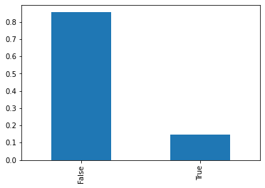

After scaling dataset, I got results from all 4 methods, ROC-AUC Curve Results show Decision Tree and SVM are pretty close, looking at their confusion matrix reveals Decision Tree (at 7 levels) performed more reliably in my case since it is binary classification I went with 'roc_auc' in *scoring* parameter of GridSearchCV:

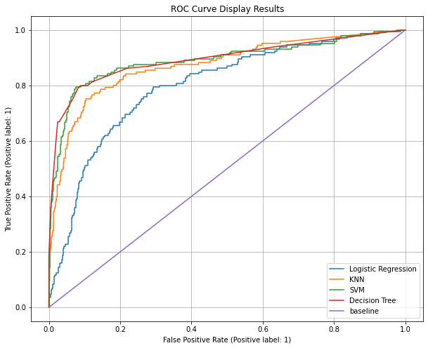

**SVM**

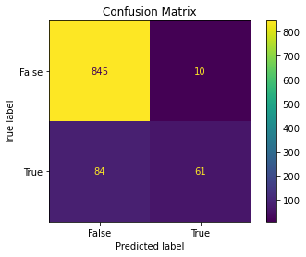

**Decision Tree**

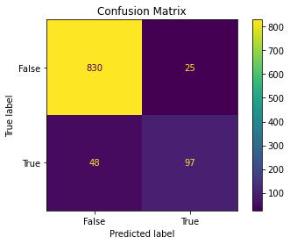

**Churn Dataset Summary Table**

|  |  |  |  |  |  |  |  |
| --- | --- | --- | --- | --- | --- | --- | --- |
| Model | Train Score | Test Score | Average Fit Time | Parameters | Is the model good at handling imbalanced classes? | Does the model train quickly? | Does the model yield interpretable results? |
| KNN | 1 | 0.873604 | 0.000652 | {'penalty': 'l1', 'solver': 'liblinear'} | Yes, KNN is not influenced by imbalanced dataset | Yes | Yes |
| Logistic Regression | 0.832071 | 0.798734 | 0.026334 | {'n_neighbors': 23, 'weights': 'distance'} | No, It is not good at inbalanced classification | OK | Yes |
| SVC | 0.975603 | 0.889994 | 0.123106 | {'gamma': 0.1, 'kernel': 'rbf'} | OK | Slower | Yes |
| Decision Tree | 0.934038 | 0.894217 | 0.008184 | {'criterion': 'gini', 'max_depth': 7, 'min_samples_leaf': 5, 'min_samples_split': 0.05} | OK | Yes | Yes |

**Digits** dataset is **balanced**, it has 1797 entries with 64 numeric array elements for digit representation:

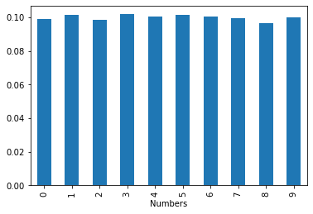

I ran all 4 methods directly with no manipulation of the dataset. SVM performed slightly better than KNN, a close look at their confusion matrix reveals, SVM has 5 misclassification versus 9 with KNN.

**SVM**

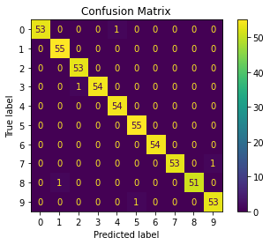

**KNN**

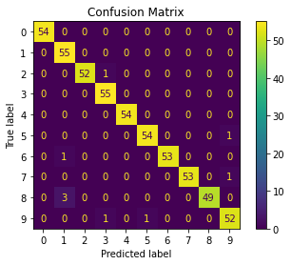

**Digits Dataset Summary Table**

|  |  |  |  |  |  |  |  |
| --- | --- | --- | --- | --- | --- | --- | --- |
| Model | Train Score | Test Score | Average Fit Time | Parameters | Is the model good at handling imbalanced classes? | Does the model train quickly? | Does the model yield interpretable results? |
| KNN | 1 | 0.983333 | 0.000443 | {'penalty': 'l1', 'solver': 'liblinear'} | Yes, KNN is not influenced by imbalanced dataset | Yes | Yes |
| Logistic Regression | 0.996818 | 0.961111 | 0.164151 | {'n_neighbors': 1, 'weights': 'uniform'} | No, It is not good at imbalanced classification | Slower | Yes |
| SVC | 1 | 0.990741 | 0.057079 | {'gamma': 0.01, 'kernel': 'poly'} | OK | OK | Yes |
| Decision Tree | 0.845664 | 0.792593 | 0.006105 | {'criterion': 'entropy', 'max_depth': 9, 'min_samples_leaf': 5, 'min_samples_split': 0.05} | OK | Yes | Yes |

**Conclusion**

Decision Tree performed better when dataset is imbalanced and SVM performed better when it is balanced, both datasets are fairly small! KNN has the best training time in both.

Lois:

**Part I**

The "Churn" column is unbalanced, with 2850 False vs 483 True observations, and the dimensions of the df (3333 x 20) makes Logistic Regression unideal for this data because it won't be able to utilize all the features or handle unbalanced classes well. In considering mean fit time, KNN and SVC takes longer to fit than Logistic Regression, but the row count is not high enough to make this a big concern. Every column in this dataset other than "State" is either already numerical or can easily be converted as such. The heatmap drew on all the data except State shows some multicollinearity among columns, such as Voice mail plan with Number vmail messages and Total day minutes with Total day charge.

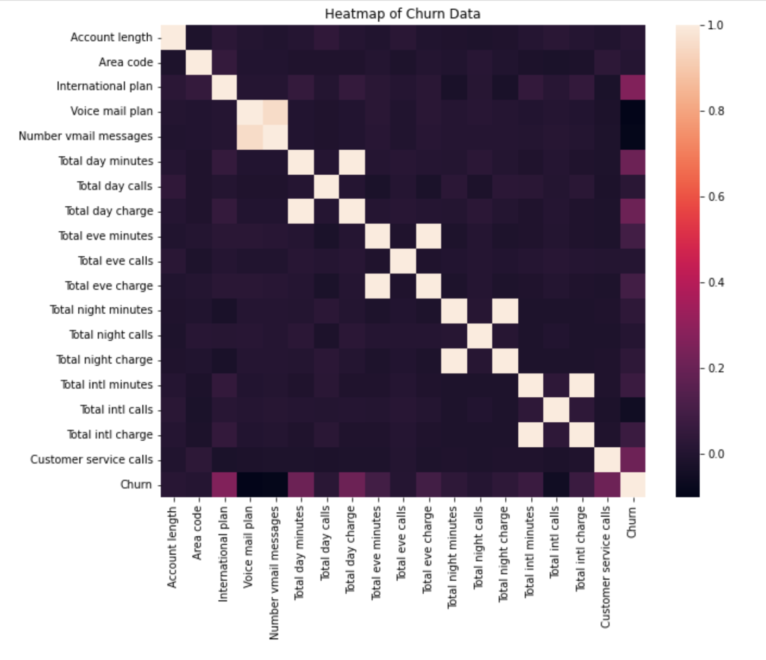

Decision trees handles multicollinearity well and is easy to interpret, but prone to overfitting and more suitable for categorical data. There is also the concern of there being overlapping datapoints, which is very possible due to the number of columms with binary values, and I'm not sure how well the rectangular decision boundaries will fit this data. SVC is not strictly necessary as the number does not exceed the number of training observations, but it can still be a good model, especially since it is capable of drawing nonlinear decision boundaries with the kernel trick. I think SVC and KNN will be the top two models for the churn dataset.

**Part II**

The dimensions of the digits data is 1797 x 64. Logistic Regression takes less time to fit, but SVC and KNN have the highest accuracy for handwritten data classification. SVC is more suited for numerical data, which makes it more appropriate than Decision Trees in this case. Additionally, SVC takes less time to compute, which is why it would be my choice of model for the digits data.

Added a sample SMOTE implementation, this was also covered in Savio live session:

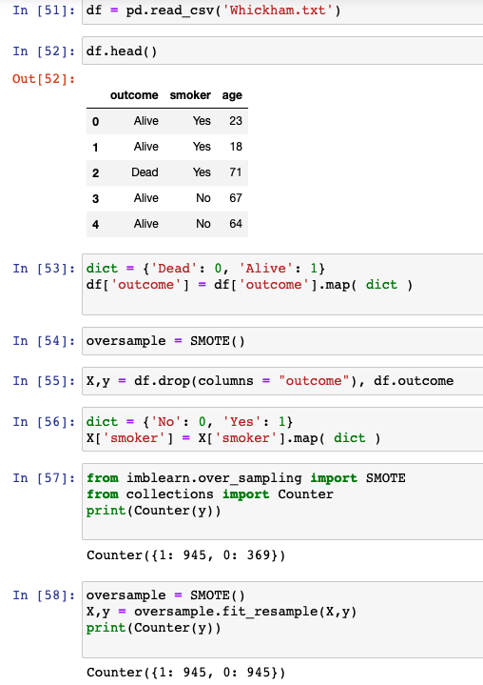

**Install imblearn**

imbalanced-learn is currently available on the PyPi’s repositories and you can install it via pip:

pip install -U --trusted-host pypi.org --trusted-host files.pythonhosted.org imbalanced-learn

pip install -U --trusted-host pypi.org --trusted-host files.pythonhosted.org pip

 ————— o —————



**Module 17**

<https://archive.ics.uci.edu/ml/datasets/bank+marketing>

**Practical Application:**

Visualization - plots/graphs

Modeling - multiple regression models

Findings - write in detail

**Comparing Classifiers**

**Overview:** In this practical application, your goal is to compare the performance of the classifiers we encountered in this section, namely k-Nearest Neighbor, Logistic Regression, Decision Trees, and Support Vector Machines. We will utilize a dataset related to marketing bank products over the telephone.

The input file in data folder!

The assignment of Jupyter notebook for bank marketing campaign model is [bank_marketing.17.Aykan.ipynb](https://github.com/Aykan-Hub/bank-marketing-campaign/blob/main/bank_marketing.17.Aykan.ipynb).

**Getting Started**

Our dataset comes from the UCI Machine Learning repository [link](https://archive.ics.uci.edu/ml/datasets/bank+marketing). The data is from a Portugese banking institution and is a collection of the results of multiple marketing campaigns. We will make use of the article accompanying the dataset [here](https://github.com/Aykan-Hub/bank-marketing-campaign/blob/main/data/bank-additional-names.txt) for more information on the data and features.

**Understanding the Data**

To gain a better understanding of the data, please read the information provided in the [article](https://github.com/Aykan-Hub/bank-marketing-campaign/blob/main/CRISP-DM-BANK.pdf), and examine the Materials and Methods section of the paper.

**How many marketing campaigns does this data represent?**

Answer: "17 campaigns that occurred between May 2008 and November 2010, corresponding to a total of 79354 contacts"

**Data Set Information**

The data is related with direct marketing campaigns of a Portuguese banking institution. The marketing campaigns were based on phone calls. Often, more than one contact to the same client was required, in order to access if the product (bank term deposit) would be ('yes') or not ('no') subscribed.

There are four datasets in the UCI link:

* [bank-additional-full.csv](https://github.com/Aykan-Hub/bank-marketing-campaign/blob/main/data/bank-additional-full.csv) with all examples (41188) and 20 inputs, ordered by date (from May 2008 to November 2010), very close to the data analyzed in [Moro et al., 2014]
* bank-additional.csv with 10% of the examples (4119), randomly selected from 1), and 20 inputs.
* bank-full.csv with all examples and 17 inputs, ordered by date (older version of this dataset with less inputs).
* bank.csv with 10% of the examples and 17 inputs, randomly selected from 3 (older version of this dataset with less inputs). The smallest datasets are provided to test more computationally demanding machine learning algorithms (e.g., SVM).

**The classification goal is to predict if the client will subscribe (yes/no) a term deposit (variable y).**

**Understanding the Features**

Examine the data description below, and determine if any of the features are missing values or need to be coerced to a different data type.

Input variables:

# bank client data:

1 - age (numeric)

2 - job : type of job (categorical: 'admin.','blue-collar','entrepreneur','housemaid','management','retired','self-employed','services','student','technician','unemployed','unknown')

3 - marital : marital status (categorical: 'divorced','married','single','unknown'; note: 'divorced' means divorced or widowed)

4 - education (categorical: 'basic.4y','basic.6y','basic.9y','high.school','illiterate','professional.course','university.degree','unknown')

5 - default: has credit in default? (categorical: 'no','yes','unknown')

6 - housing: has housing loan? (categorical: 'no','yes','unknown')

7 - loan: has personal loan? (categorical: 'no','yes','unknown')

# related with the last contact of the current campaign:

8 - contact: contact communication type (categorical: 'cellular','telephone')

9 - month: last contact month of year (categorical: 'jan', 'feb', 'mar', ..., 'nov', 'dec')

10 - day_of_week: last contact day of the week (categorical: 'mon','tue','wed','thu','fri')

11 - duration: last contact duration, in seconds (numeric). Important note: this attribute highly affects the output target (e.g., if duration=0 then y='no'). Yet, the duration is not known before a call is performed. Also, after the end of the call y is obviously known. Thus, this input should only be included for benchmark purposes and should be discarded if the intention is to have a realistic predictive model.

# other attributes:

12 - campaign: number of contacts performed during this campaign and for this client (numeric, includes last contact)

13 - pdays: number of days that passed by after the client was last contacted from a previous campaign (numeric; 999 means client was not previously contacted)

14 - previous: number of contacts performed before this campaign and for this client (numeric)

15 - poutcome: outcome of the previous marketing campaign (categorical: 'failure','nonexistent','success')

# social and economic context attributes

16 - emp.var.rate: employment variation rate - quarterly indicator (numeric)

17 - cons.price.idx: consumer price index - monthly indicator (numeric)

18 - cons.conf.idx: consumer confidence index - monthly indicator (numeric)

19 - euribor3m: euribor 3 month rate - daily indicator (numeric)

20 - nr.employed: number of employees - quarterly indicator (numeric)

Output variable (desired target):

21 - y - has the client subscribed a term deposit? (binary: 'yes','no')

**Data Cleaning and Transformation**

There are categorical variables in the dataset, I will transform them before further analyze them.

**Analyze Features**

Some features have *unknown* values, this may impact the models, by checking the feature importance chart, one approach is to assign null to less important features, remove those null tuples from the dataset later on. Especially, day_of_week, loan and housing are at the bottom, I will remove them so no null assignment for them.

|  |  |  |  |  |
| --- | --- | --- | --- | --- |
| **Feature** | **Importance** |  |  |  |
| emp.var.rate | 0.093042 |  |  |  |
| poutcome | 0.047772 |  |  |  |
| cons.conf.idx | 0.026913 |  |  |  |
| contact | 0.005341 |  |  |  |
| default | 0.001988 |  |  |  |
| job | 0.001256 |  |  |  |
| age | 0.000928 |  |  |  |
| month | 0.000579 |  |  |  |
| campaign | 0.000469 |  |  |  |
| marital | 0.000361 |  |  |  |
| housing | 0.000024 |  |  |  |
| loan | 0.000004 |  |  |  |
| day_of_week | -0.000019 |  |  |  |
| education | -0.000128 |  |  |  |

Although, it is shown in the list education seems to have some influence especially in illiterate people's case. So, I will keep it in the list, I can consider dealing with unknown values in later phases.

**Columns Transformations**

**Although, this can be done with encoders, I went with direct transformation since I worked on them to analyze each feature, also, I used them in correlation matrix after the transformation:**

1. job is categorical, I used factorize to transform it to numeric
2. marital is categorical, I used factorize to transform it to numeric
3. education is categorical, I used mapping to transform it to numeric: {'basic.4y':2,'basic.6y':3,'basic.9y':4,'high.school':5,'illiterate':1,'professional.course':6,'university.degree':7,'unknown':0}
4. features default, housing and loan have yes/no/unknown values, mapped as: {'no':1,'yes':2,'unknown':0}
5. education is categorical, I used mapping to transform it to numeric: {'mon':1,'tue':2,'wed':3,'thu':4,'fri':5}
6. poutcome is categorical, I used mapping to transform it to numeric: {'failure':1,'nonexistent':0,'success':2}

**Finally, I transformed the target variable y, yes/no values to 1/0**

**Feature Overlapping**

The subset of data is considered for a baseline model which has only 7 bank-client features: 'age', 'job', 'marital', 'education', 'default', 'housing' and 'loan'. This yields 2085 unique groups of feature overlapping failing to identify yes/no classes in y distinctly. This is effecting 19528 rows in the entire population which is 47% of dataset.

The full dataset has 237 unique groups of feature overlapping failing to identify yes/no classes in y distinctly. This is effecting 3665 rows in the entire population which is 9% of dataset, this is impacting the ability of models to predict outcome for such corner cases.

These observations should be kept in the baseline calculation.

**Features**

Senior people after age 60 accept campaigns more, so do illiterate people, in contrast to that all professions seem to preserve the same ratio!

[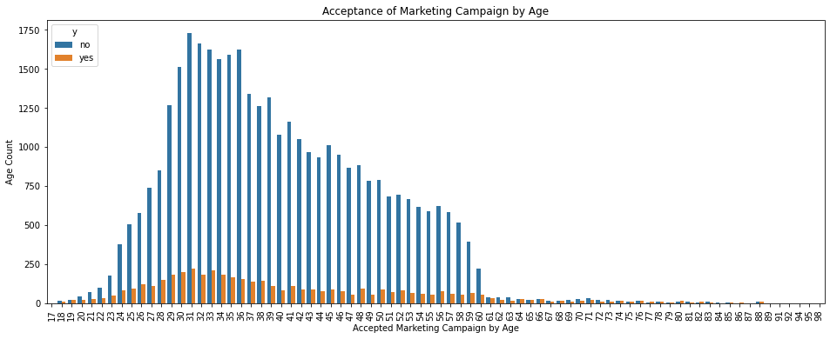](https://github.com/Aykan-Hub/bank-marketing-campaign/blob/main/images/age.png)

**Business Objective**

Due to domestic competition and current financial crisis, there is a huge pressure on European banks to increase financial asset. To overcome this issue, one strategy would be to offer attractive long-term deposit applications with good interest rates, particularly by using directed marketing campaigns. Also, the same economic factors apply for cost reduction and time.

Thus, there is a need for improvement in efficiency: lesser customer contacts must be done, but on the otherhand same success rate must be retained, namely rate of *clients subscribing to the deposit* must be retained.

**A Baseline Model**

Before we build our first model, we want to establish a baseline. What would be the baseline performance that our classifier should aim to beat?

The distribution of target variable shows 89% of observations is No, only 11% is Yes shown in below plot:

[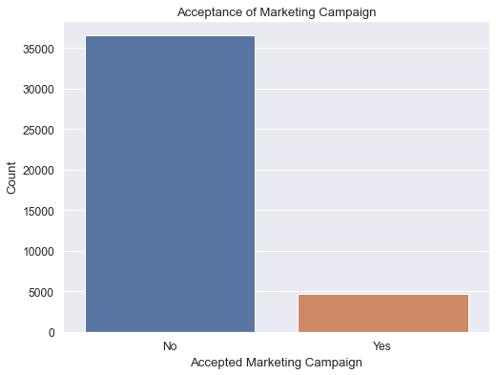](https://github.com/Aykan-Hub/bank-marketing-campaign/blob/main/images/AcceptanceofMarketingCampaign.png)

The baseline is 89% by the target variables outlined in the count plot, the model should be better than this baseline! However, the feature overlapping rate above indicates only 53% can be properly classified, 47% being arbitrarily due to feature overlapping. If we assume 50-50, best we can get is 77% for this dataset as baseline versus simply rely on 89% by the target observations.

After running all 4 models with default hyperparameters, the outcome on recall metric is not very promising, the outcome of Logistic Regression, k-Nearest Neighbors, Decision Tree and Support Vector Machines all performed poorly, there is no outstanding result:

|  |  |  |  |  |
| --- | --- | --- | --- | --- |
| **Model** | **Train Time** | **Train Accuracy** | **Test Accuracy** |  |
| Logistic Regression | 0.013428 | 0.000000 | 0.000000 |  |
| KNN | 0.012411 | 0.126886 | 0.063937 |  |
| Decision Tree | 0.031382 | 0.308901 | 0.099856 |  |
| SVM | 19.583614 | 0.016939 | 0.009339 |  |

The score of Logistic Regression came out as 0.0 and fastest, SVM being the slowest of all.

**Improving the Model**

**Dataset Allocation**

Since all features transformed to numeric representation, a correlation matrix can be checked since there are not many features in the dataset:

[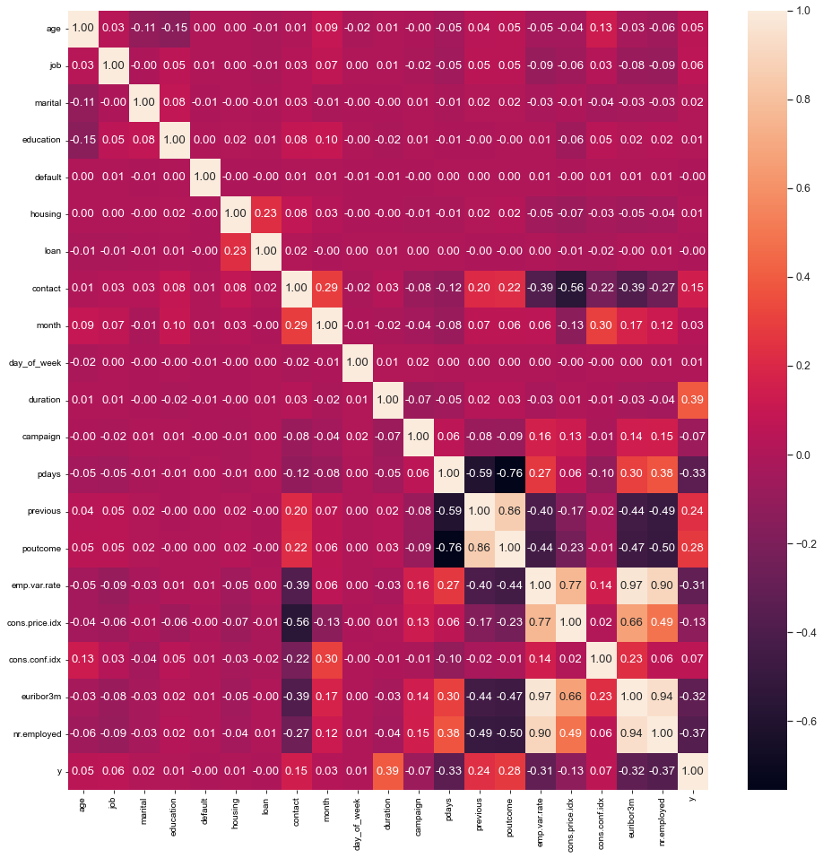](https://github.com/Aykan-Hub/bank-marketing-campaign/blob/main/images/correlationmatrix.png)

Per correlation matrix above, there are some strong correlation among these independent variables which is indicating multicollinearity in the dataset:

* poutcome strongly correlated with pdays (negative) and previous (positive)
* emp.var.rate strongly positive correlated with cons.price.idx, euribor3m and nr.employed I can safely remove those features which are highly correlated above 75%. Later, I would run a multicollinearity analysis on the dataset to verify those findings.

Also, 9% of full dataset cannot be correctly classified as the remaining features on it cannot distinctly define boundaries in the final outcome. Again, if we assume 50-50 distribution, the best outcome will be 95% but realiably accurate outcome is 91% on the full dataset.

Please also note that, duration feature is only known after a call to customer is completed which is an after-the-fact feature, is not available upfront for executing a model. Therefore, it is should be stripped off the dataset.

So these are the features must be removed before proceeding any further with enhanced analysis and model executions: 'duration', 'pdays', 'previous', 'cons.price.idx', 'euribor3m', 'nr.employed'

**Multicollinearity Analysis**

I ran multicollinearity analysis on the remaining dataset, there is nothing above 5 in the list pointing multicollinearity by running Variance Inflation Factor (VIF):

|  |  |
| --- | --- |
| **Feature** | **VIF** |
| emp.var.rate | 1.583261 |
| contact | 1.563009 |
| month | 1.380385 |
| poutcome | 1.280853 |
| cons.conf.idx | 1.271658 |
| default | 1.128615 |
| education | 1.104042 |
| age | 1.092416 |
| housing | 1.063655 |
| loan | 1.055819 |
| marital | 1.028582 |
| campaign | 1.027430 |
| job | 1.014802 |
| day_of_week | 1.001330 |

**Feature Importance**

Also, one more check to complete is feature importance, I ran that too:

|  |  |
| --- | --- |
| **Feature** | **Importance** |
| emp.var.rate | 0.093042 |
| poutcome | 0.047772 |
| cons.conf.idx | 0.026913 |
| contact | 0.005341 |
| default | 0.001988 |
| job | 0.001256 |
| age | 0.000928 |
| month | 0.000579 |
| campaign | 0.000469 |
| marital | 0.000361 |
| housing | 0.000024 |
| loan | 0.000004 |
| day_of_week | -0.000019 |
| education | -0.000128 |

Also, I ran L1 Regularization to see what features picked:

[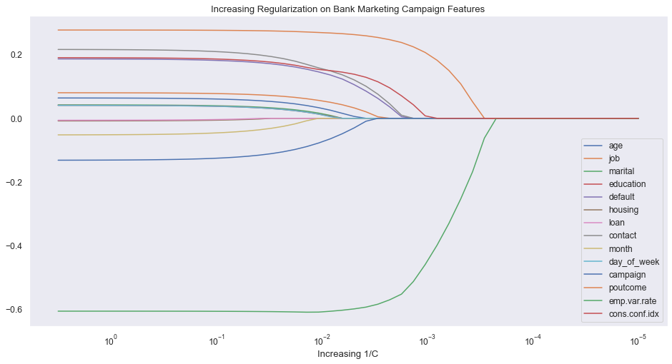](https://github.com/Aykan-Hub/bank-marketing-campaign/blob/main/images/IncreasingRegularizationonBankMarketingCampaignFeatures.png)

Features loan, housing, day_of_week and month seem less important in this plot. loan and day_of_week features are also bottom 2 in the permutation importance list. Also, note education feature is second most important, so, I will not remove that feature.

Further, After the feature engineering methods revealed bottom features, I removed loan, housing, and day_of_week columns and split dataset again. Beyond that, the multicollienarity check by Variance Inflation Factor (VIF) did not point out any features. Going with the scaled dataset after removing 3 less important features from the X dataset, namely: 'loan', 'housing', 'day_of_week'

**SMOTE method**

The dataset is severely imbalanced having 11% acceptance rate and 89% not accepting. Applying SMOTE to have equal number of data entries on either classes of target observation Yes/No.

**Standardization**

Standardization is applied to the dataset in order to avoid small features penalized heavily by the penalty term since features are skewed.

**Model Building**

All 4 models Logistic Regression, k-Nearest Neighbors, Decision Tree and Support Vector Machines were built and fed into GridSearchCV by using roc_auc in scoring hyperparameter since it is binary classification per manual: “A receiver operating characteristic (ROC), or simply ROC curve, is a graphical plot which illustrates the performance of a binary classifier system as its discrimination threshold is varied. It is created by plotting the fraction of true positives out of the positives (TPR = true positive rate) vs. the fraction of false positives out of the negatives (FPR = false positive rate), at various threshold settings. TPR is also known as sensitivity, and FPR is one minus the specificity or true negative rate.”

Each model fed with hyperparameter list to evaluate best outcome, they are captured in a table.

**Model Results**

k-Nearest Neighbors with *91%* is pretty close to our performance metric projection due to feature overlapping. Decision Tree is pretty good too, their train time is pretty close 31 seconds each and reasonable with the magnitude of data. However, Logistic Regression is one click better than Support Vector Machine and fastest train time. SVM took over an hour to train with no parallelism and performed worst in both test accuracy and train time.

|  |  |  |  |  |
| --- | --- | --- | --- | --- |
| **Model** | **Train Time** | **Train Accuracy** | **Test Accuracy** | **Hyperparameters** |
| Logistic Regression | 0.033166 | 0.759782 | 0.763205 | {'C': 100, 'max_iter': 1000, 'solver': 'lbfgs'} |
| k-Nearest Neighbors | 0.030518 | 0.995653 | 0.908220 | {'n_neighbors': 13, 'p': 1, 'weights': 'distance'} |
| Decision Tree | 0.071775 | 0.929373 | 0.891593 | {'criterion': 'entropy', 'max_depth': 33, 'min_samples_leaf': 2, 'min_samples_split': 0.001} |
| Support Vector Machine | 55.611333 | 0.746876 | 0.750658 | {'C': 0.001, 'cache_size': 1000, 'gamma': 0.01, 'kernel': 'rbf'} |

[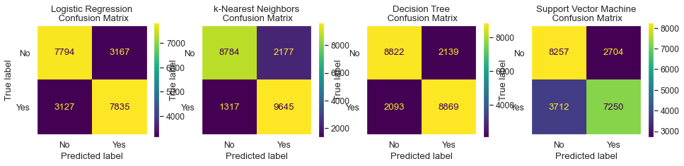](https://github.com/Aykan-Hub/bank-marketing-campaign/blob/main/images/LogisticRegression.png)

The logistic regression came out with a weaker C hyperparameter for regularization and chose lbfgs as solver and being fastest. KNN chose 13 neighbors and best estimator, followed by Decision Tree went with entropy more computationally heavy than gini but train time still less than KNN due to less hyperparameter combinations. Finally, Support Vector Machine came out as the worst performer in both time and score although it picked slightly smaller gamma which is higher dimension also higher bias and smaller variance by C.

As shown in the confusion matrix, KNN has fewer misclassifications, and better area under the curve (AUC) below:

](https://github.com/Aykan-Hub/bank-marketing-campaign/blob/main/images/ROCCurveDisplayResults.png)

As shown in Receiver Operating Characteristics curve, the performance of KNN and Decision Tree similar and similarly Logistic Regression and Support Vector Machines.

**Next Steps**

**What are next steps?**

* I briefly highlighted "unknown" values in categorical variables, job and marital features are highly influential, those unknown values should be removed from the dataset to try out again in those models
* Secondly, overlapping features should be addressed in the dataset which brings ambiquity to those models, once they are cleared, models should be reevaluated for better performance
* SVM could be tried with poly kernel and higher degrees, however, it is very CPU-intensive should be on a dedicated computer
* Logistic Regression with various solver and C hyperparameter values

**Conclusion**

k-Nearest Neighbors came at *91%* outperformed all other models which is inline with my performance metric projection due to the overlapping features. Second best is Decision Tree, its train time is also the second best was 31 seconds. Logistic Regression and Support Vector Machine models are the worst performers. Especially, SVM with no parallelism took over an hour to train the model, it is very costly but yielding not far better results.

KNN is best performing, easy to train and second less costly after Logistic Regression.

repo: <https://github.com/Aykan-Hub/bank-marketing-campaign>

It is worth to check out ROC-AUC explanation: <https://towardsdatascience.com/understanding-auc-roc-curve-68b2303cc9c5>

**Capstone Project**

8/17 - 9/5 schedule meeting with instructors

Finalize problem statement!

Congratulations! You have now completed the three practical application assignments. There will be no further cumulative projects except for your final capstone project.

You should already have proposed a question to answer in your final capstone and looked at possible datasets and techniques. A few modules ago, you should have met with your Learning Facilitator to refine your question and generate ideas for datasets and techniques. Now, it is time to submit the official proposal.

In this discussion board, your initial post should contain the following:

1. The research question you intend to answer (one sentence, if possible)
2. Your expected data source(s) (either a link to existing data or a sentence describing where you will source the data from)
3. The techniques you expect to use in your analysis
4. The expected results
5. Why this question is important

That last bullet point is the most important. Remember, your final capstone project will be graded not only on the execution of your plan but also on your ability to translate those results into actionable business intelligence that can be acted upon by non-AI/ML personnel. Not only will you have to do the number crunching, but you will also have to distill the results into something understandable by the general public. This last bullet point is your opportunity to explain (in non-AI/ML language) why this question is important. What happens if this question is unanswered? What benefit will your analysis bring?

EDA Analysis

I outlined my **research topic** and proposal below.

**The research question you intend to answer (one sentence, if possible)**

* When clients are interacting with our system, typically they are on happy path but occasionally they deviate from it which may result in negative experience while impacting customer interactions, I would like to predict those negative experiences at any given time by checking past 15 customer interaction data points over 30 days, even if there is more, the set is restricted to most recent 15 actions.

**Your expected data source(s) (either a link to existing data or a sentence describing where you will source the data from)**

* I fabricated such data and defined the data model what would need to look for, represented by columns as below, all features are numeric, interactions are transformed into numerical codes.
* id is a unique identifier per row which bundles interactions together in the row
* *prev_action_15*

through

* *prev_action_1* columns
  1. they contain previous interaction codes, from oldest to newest action code: **prev_action_15** being oldest and **prev_action_1** being most recent in the data model representation
  2. If there are not enough data points in client interaction history, 0 will be placed in these previous action columns. Please note, semantically, zeros will start appearing from prev_action_15 (from oldest to newest). 0 cannot be on prev_action_1 which means no entry over 30 days for this client!
* **action** is the target column
* Sample data below:

|  |  |  |  |  |  |  |  |  |  |  |  |  |  |  |  |  |
| --- | --- | --- | --- | --- | --- | --- | --- | --- | --- | --- | --- | --- | --- | --- | --- | --- |
| id | prev_action_15 | prev_action_14 | prev_action_13 | prev_action_12 | prev_action_11 | prev_action_10 | prev_action_9 | prev_action_8 | prev_action_7 | prev_action_6 | prev_action_5 | prev_action_4 | prev_action_3 | prev_action_2 | prev_action_1 | action |
| 19059237 | 104 | 158 | 131 | 72 | 179 | 75 | 75 | 73 | 180 | 180 | 179 | 180 | 75 | 55 | 75 | 55 |
| 73879930 | 0 | 0 | 0 | 75 | 77 | 162 | 75 | 75 | 75 | 75 | 75 | 111 | 111 | 55 | 75 | 55 |

Note to the second line entry, there are not enough entries, so, 3 0s in those columns.

**The techniques you expect to use in your analysis**

* This first phase focus is binary classification ,specifically the techniques I would like to utilize are Logistic Regression and Decision Tree.

**The expected results**

* The expected result is predicting **action** column in my dataset and also discover interaction patterns. In the initial phase, my approach will be two models to predict action code = 55 and 142 respectively. Optionally, the next phase will be a multi-class model to predict multi-class action code = 55 and/or 142 with probability as multinomial model but this is not a deal breaker.

**Why this question is important**

* This is a preliminary work in parallel to an ongoing work, I would like to apply the techniques I learnt, see if it helps in anyway to identify those patterns in the dataset, or any improvement point I could bring up comparing my results with the existing. A working classification model is highly desired here to compare its performance with the existing outcome.

**What to use?**

Project: <http://localhost:8888/notebooks/training/capstone/capstone.Aykan.ipynb#>

All Used techniques in <http://localhost:8888/notebooks/training/ML-AI-Education/Berkeley/module12/Try_it_12.1_starter/try_it_12.1.Aykan.ipynb>

Just decision trees: <http://localhost:8888/notebooks/training/ML-AI-Education/Berkeley/module14/try_it_14.2.Aykan.ipynb>

All: <http://localhost:8888/notebooks/training/ML-AI-Education/Berkeley/module16/try-it_16_1_starter/try_it_16.1.Aykan.ipynb#Churn>

Last: <http://localhost:8888/notebooks/training/bank-marketing-campaign/bank_marketing.17.Aykan.ipynb#Apply-SMOTE-method>

It is worth to check out ROC-AUC explanation: <https://towardsdatascience.com/understanding-auc-roc-curve-68b2303cc9c5>

**Notes:**

Making models more interpretable machine learning models: <https://christophm.github.io/interpretable-ml-book/counterfactual.html#counterfactual>

How to understand the outcome of a model

<https://github.com/interpretml/DiCE>

Dataset: <https://github.com/SavioSal/datasets/raw/master/Default.csv>

**Module Issues:**

**Quizes:**

 ————— o —————

**Module 18**

**Notes:**

**Module Issues:**

**Quizes:**